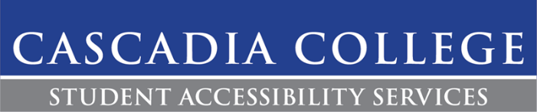

Audio Recording Accommodation

Description:
Cascadia College may determine a student has permission to record audio lectures as a reasonable accommodation. For some students, this is a necessary accommodation that allows them to gain full advantage of the course, which might not otherwise be fully accessible to them.

Student Responsibilities:
- If students intend to record class sessions, please notify your instructor at the beginning of the quarter. Even if the student is unsure if they will be utilizing the accommodation throughout the course (dependent on the course format), this is the student’s choice since they are entitled to the accommodation should they wish to access it.
- Discuss with their instructor about whether a course involves personal reflection, self-disclosure, or confidential discussions.
- Recording of classroom lectures are for educational purposes only. Recordings cannot be posted online, shared with others, or distributed without explicit permission from the instructor. Students who violate this policy will be referred to the office of Student Conduct and are subject to disciplinary action.
- Recordings are to be deleted 7 days after grades have been issued. In the event you need to retain the audio recordings after the class has concluded, you must request written permission from the instructor and they will make the determination if the recordings can be retained.

Faculty Notes:
- Faculty may make the following confidential announcement to the class at the beginning of the quarter: “Some class sessions may be recorded for educational purposes, recordings will not be distributed and will be deleted at the end of the quarter”.
- If students are sharing and discussing information of self-disclosure as part of the class, instructors may ask the class from recording the portion of lecture. If these open discussions are not appropriate subject matter for any student to be taking notes, it would be appropriate to issue a general announcement to the class to request that any students taking notes or using a recording device refrain from doing so.

Contact:
If there are any questions or concerns regarding this accommodation, please contact SAS at 425.352.8261 or by emailing accessibility@cascadia.edu.

