EAB Meeting Minutes

Time 2:00 PM| Date 12/06/2024| Location ARC 110

1. Call to order: 2:04pm
2. Roll call of EAB members
   1. Advocacy Chair – Olivia Kent-Horton- Present
   2. Programming Chair – Leila De Folo- Present
   3. Molika Ny- Present
   4. Shaezel Khan- Present
   5. Taylan Allison - Present
   6. Jack McChesney – Present
3. Approval of minutes
   1. Taylan Motions to approve, Shaezel Seconds
   2. Motion Passes 5/0/0
4. Approval of agenda
   1. Shaezel Motions to approve with Changes; Taylan Seconds
   2. Motion Passes 5/0/0
5. Open Forum
6. Special guests & funding requests
   1. Dr. Brian- MOBAS Programming App Presentation
      1. EAB Assisting- Marketing to app Testers, and collecting the feedback about the App
7. Member reports
   1. Advocacy Chair – Olivia Kent-Horton
      1. College 101 Report and Advocacy Question of the week [Debrief](https://forms.office.com/pages/responsepage.aspx?id=2e8FJV2fQUmGXAPJsbiGExmAkOtoKXdLkXd-6iAw1axUNDFDR1gwSVk3R0tRRDYxTU5VUDlFWDNDVi4u&route=shorturl)
   2. Programming Chair – Leila De Folo
      1. [Mood Mixer Debrief](https://forms.office.com/r/ch2qQpFfps)
         1. Tabled to next meeting on 12/13
      2. When we have a lot of cardboard boxes, we can break them down and leave them behind the recycle bin in the workroom
      3. Do we need a digital version of the EAB to-do list as well as the whiteboard in the office?
         1. Keeping it the same- white board focus
      4. We have a silver shelf at the back of the ILO where we can store things for an upcoming event
      5. Would like some more details about what goes into the idea we talked about earlier in the quarter of each EAB member going to 1 club meeting per quarter
         1. Tabled to be discussion at a January EAB meeting
      6. Winter Wave Goodbye - the agendas and shift schedule have been made and those will be printed and available for everyone on my desk. Also, the last person to table needs to restock cups/supplies and get the carts loaded for the next day. [12/9](https://cascadiacc.sharepoint.com/:x:/s/CascadiaStudentLife-EAB/EY4xtYQNzUVOhO94gLRTQCcBLDYKx09n1IXCLFlZ4IXT2w?e=YyDVSU), [12/10](https://cascadiacc.sharepoint.com/:x:/s/CascadiaStudentLife-EAB/EbmvcSPLKu9HjDZ_yIvEmGYBHgl9jJvN5NLgobk6ukm1Hg?e=PpbYsP), [12/11](https://cascadiacc.sharepoint.com/:x:/s/CascadiaStudentLife-EAB/ER0v-Q1itqNPjzA1szzhXWcBm98sQ_frmaZU_DEWkV2SpQ?e=8CR3Ka), [12/12](https://cascadiacc.sharepoint.com/:x:/s/CascadiaStudentLife-EAB/EQdK27hr4aJNri4IzGlD7hwBIVuLbiiHbYZoOhgii6G8tA?e=RxvLYF) Who has office hours an hour before our event start time that can set up the hot water heater?
      7. We are wearing dark blue Kodiaks shirts for Winter Wave Goodbye
   3. Molika Ny
      1. [Lunar New Year proposal](https://cascadiacc.sharepoint.com/:w:/s/CascadiaStudentLife-EAB/EVuO3HYmziVDiTLatqeFLeMBYLNHwezqmXaHB_H_YS6TNw?e=SxqMZ7) (nen ed extra time please)
         1. TOD- Date February 12th
         2. 3PM-5:30PM
         3. Let Moli know if you have any decor ideas
      2. Socks proposal at Involvement fair
         1. EAB will be CC’d on Moli’s Email
      3. Reminder on what I am up to currently: Winter wave goodbye, College 101 Olivia (feed back, marketing and future project), Lunar NY(IP collab), Organization website/doc.
      4. day in a life of student life video idea
         1. Table to next weeks meeting 12/13
   4. Shaezel Khan
      1. De-Stress Fest final comments: Had a total of 229 people inside the overlook and (322) at the petting zoo.
         1. If you have anything to add share with Shaezel
      2. Casino Night
         1. January 29th 4pm-7pm in ARC Overlook
         2. Proposed theme is a Squid Game themed
         3. If there are any ideas share with Shaezel through teams, Meeting with Phong 12/13 deadline is 12/12
   5. Taylan Allison
      1. New Date for Global Gratitude: January 22nd
      2. Time Idea- 3-6pm
      3. Confirmed with ARC, Vendors are being contacted, and then shared with IP and Clubs involved
   6. Jack McChesney
      1. Save the date! Winter Involvement Fair
         1. Wed 1/15 and Thur. 1/16 12:30 – 2:30
         2. Will be meeting with Sam to work on the planning
      2. Club Council Updates
         1. Went well (Jack’s first meeting)
         2. Clubs are still joining the involvement fair for winter
         3. Olivia gave a speech about college 101 and a bit about common hour
8. Advisor reports
   1. Shandy Stomieroski
      1. Key check out - reminder to put keys away before you leave the office at the end of your shift
      2. Required HR training: "Title IX" due by Dec 18 - you received an email from <https://cascadia-wa.vectorlmsedu.com>
         1. Next week fill out the form, may be able to fill out at home with permission from Shandy
         2. 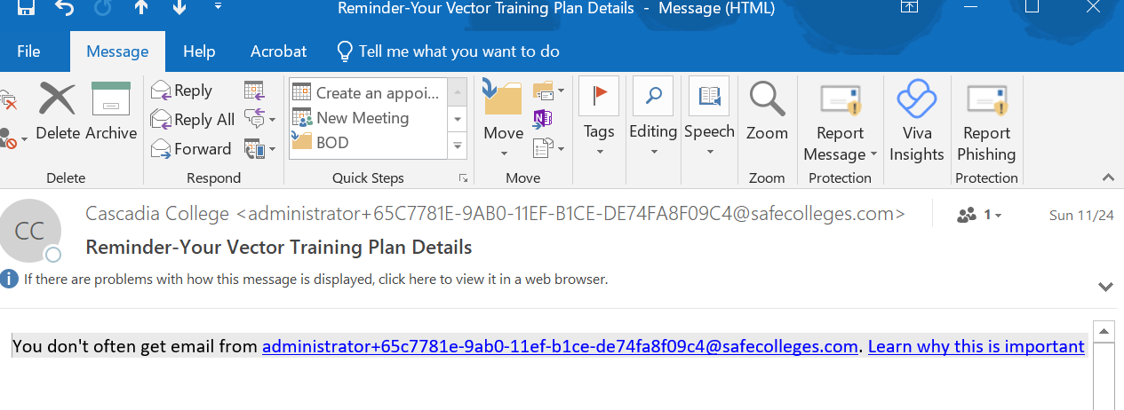
      3. Tablecloths: Nice black round/rectangle to be used for non messy tables, paint stained tablecloths to be used for messy craft tables, EAB table cloth should be used to rep EAB table (shouldn't be used for a messy table: ie: slime, painting, syrups that stain, etc.)
      4. [Tablecloth wash process](https://cascadiacc.sharepoint.com/:w:/s/CascadiaStudentLife/Eemgnf3r2axNtScgzTFpBiwB6uZlc4dSwGrnbk84wW0sjA?e=myTegk)
      5. SW Board placement: reminder to not block entrance, egress, elevators, halls, accessibility buttons
         1. If you want a SW board out EAB has to put them out and back until further notice
      6. Finals week expectations- tabling, office hours, 1:1s (end of quarter review)
         1. If you can’t make your one on one with Shandy next week reschedule before you leave today-
         2. If you need to change your scheduled office hours also let Shandy know
      7. End of quarter party next week, Wed, Dec 11 at 3:30 in ARC 121
      8. [Winter EAB Meeting Time](https://www.when2meet.com/?27861887-l1U27)
         1. Mondays 3:30-5:30
      9. Hot water maker: Do not move when hot! If you need to transport hot water/coffee, please use large black Cambro OR small air pots.
   2. Becky Riopel
      1. Title IX training
      2. Mini meeting room usage/requests
9. Committee reports
   1. ARC Advisory/SFAC -
      1. Met 12/6
      2. Reservation Space is filling up
   2. Bothell Dining Advisory Committee -
      1. 12/6
      2. Trying to get more feedback-
      3. EAB would fill out the form
      4. Hot soup added to quad market
      5. Grub Hub from Gold brew and Village Cafe starting winter Quarter
      6. POD Market is open - everything else will be closed
   3. Budget Council -
      1. Will meet again in Winter Quarter
   4. Campus Community Safety & Wellbeing Advisory Council -
      1. Not met yet
   5. CC5 Public Art Committee -
      1. 12/5
      2. Introductory meeting
         1. 2 proposed options
         2. External artwork or internal piece
   6. College Advisory Council -
      1. Shared common hour information
      2. Shared student voice/experience on the power outage
   7. Commuter Services Advisory -
      1. 12/6
      2. Noise complaints areas from west garage
      3. Thinking about putting in a traffic sign or warning to decrease speeding
      4. Parking revenue – that would increase parking rates over the next 3 years
      5. Increase communication to students about the reason for higher parking rates and would like EAB and Student Feedback
      6. Share and Ask questions at next EAB 12/13
   8. Hazing Prevention Committee -
      1. Not met yet
   9. Information Security Management Council -
      1. Meeting soon
   10. Student Learning Council -
       1. Met 12/4
       2. Planning to rename projects and assignments in College 101
       3. They are also redesigning the College 101 curriculum
       4. College 101 feedback is being collected by Librarians, Office of Equity & Inclusion – EDP instructor in the library and
       5. Updated the IT CS programming course will be taken out of program sequenced requirement but will be put in as elective, with placement test
       6. Water 197 and 297- Updating the classes, to be an internship and/or volunteer class with the invitation of a professor
       7. Deactivating Astronomy 100, ENV Science 140, ENV Science 210, Geology 250
       8. Statewide committee update – taking Running Start students who want to transfer to with an AA more seriously rather than making the take 4 years ago
       9. College is looking at using AI in professional development
       10. Business major requirements will be more structured
   11. Student Success Council -
       1. Not met yet
   12. Sustainability -
       1. Not met yet
10. Unfinished business/New business:
    1. Advocacy Question of the week: What do we want to ask students this week?
       1. College 101 Survey and Questioning for Data Collection
    2. Upcoming Tabling dates
       1. Winter Wave Goodbye - 12/9, 12/10, 12/11, 12/12
11. Announcements:
    1. Reply to Fluffy Socks email by Monday - 12/9
    2. If anyone would like to use the EAB Rented Phone for the app bring back to Shandy
12. Adjournment: 4:17pm