EAB Meeting Minutes

Time 3:30 PM | Date 01/06/2025| Location ARC-110

1. Call to order: 3:38pm
2. Roll call of EAB members
   1. Advocacy Chair – Olivia Kent-Horton- Present
   2. Programming Chair – Leila De Folo- Present
   3. Molika Ny- Present
   4. Shaezel Khan- Present
   5. Taylan Allison- Present
   6. Jack McChesney- Present
3. Approval of minutes
   1. Taylan Motions to Approve; Jack Seconds
   2. Motion Passes 5/0/0
4. Approval of agenda
   1. Taylan Motions to Approve; Jack Seconds
   2. Motion Passes 5/0/0
5. Open Forum
6. Special guests & funding requests
7. Member reports
   1. Advocacy Chair – Olivia Kent-Horton
      1. Reminder- Common Hour Delegated Task List
         1. Nothing else will be added at this time
      2. I can assist in filming the EAB Kodiak News segments during my office hours this week will be available Tue 9:30 am to 12:30pm, Wed 2pm-4pm, Thurs 9:30am to 12:30pm, and Fri 12:30 to 3:00pm
   2. Programming Chair – Leila De Folo
      1. Confirming everyone's office hours so I can create the schedule to put around the office
         1. Yes all office hours have been updated
      2. Please create handbills for Lunar New Year and Casino Night before Involvement Fair on January 15 and 16 so that we can hand them out
      3. What design do we want to put on the chapsticks we are ordering and where do we want to give them out?
         1. More Generic Cascadia Designs so they can be used during winter and spring quarter
   3. Molika Ny
   4. Shaezel Khan
      1. Any ideas for Casino Night teams me by January 10th
         1. Still continuing under the theme of Squid Games
   5. Taylan Allison
      1. [Sustainability committee survey](https://nam11.safelinks.protection.outlook.com/?url=https%3A%2F%2Fforms.gle%2F2rx8jVjqeZwLEmFk8&data=05%7C02%7Ctallison%40cascadia.edu%7C227c4bc001354ade323108dd035ef32e%7C2505efd99f5d4941865c03c9b1b88613%7C0%7C0%7C638670428530971380%7CUnknown%7CTWFpbGZsb3d8eyJFbXB0eU1hcGkiOnRydWUsIlYiOiIwLjAuMDAwMCIsIlAiOiJXaW4zMiIsIkFOIjoiTWFpbCIsIldUIjoyfQ%3D%3D%7C0%7C%7C%7C&sdata=Hg9j1sKXPzIAXlODI5j9TZC3MdEQog3YQeNK3DV3x7Y%3D&reserved=0)
         1. Must be 18 to complete the survey
      2. Global Gratitude Update
         1. Confirmed with 4 catering and setting up a meeting with the participating clubs
   6. Jack McChesney
      1. Gathering marketing ideas from EAB for Winter Involvement Fair
         1. Idea’s given to Jack by Wed 8th
8. Advisor reports
   1. Shandy Stomieroski
      1. Address Attestation form from HR - Fill out before you leave today if you have not already done so
         1. When done teams Shandy that you have finished
      2. Title IX Training - Who has completed this training?
         1. Everyone has completed (except Jack who has an extension)
         2. Good work, high fives all around
      3. Tabling opportunities this week: Tues 9-12, Wed 9-12, Thurs 12-3
         1. These times are available to assist if you would like to help go to student life Trello tabling under welcome week tabling and put your name on the empty time slot.
      4. Deadline for TP Times is Wed at 5pm for 1/17 - 1/31
      5. New printer in ARC - 135, please double check to make sure you are able to print
         1. Let Advisors know when issues come up for assistance before you are under a deadline
      6. Vote on Kody sticker in Student Life chat by Friday
         1. Ice Skating Kody
      7. LBA Update!
         1. 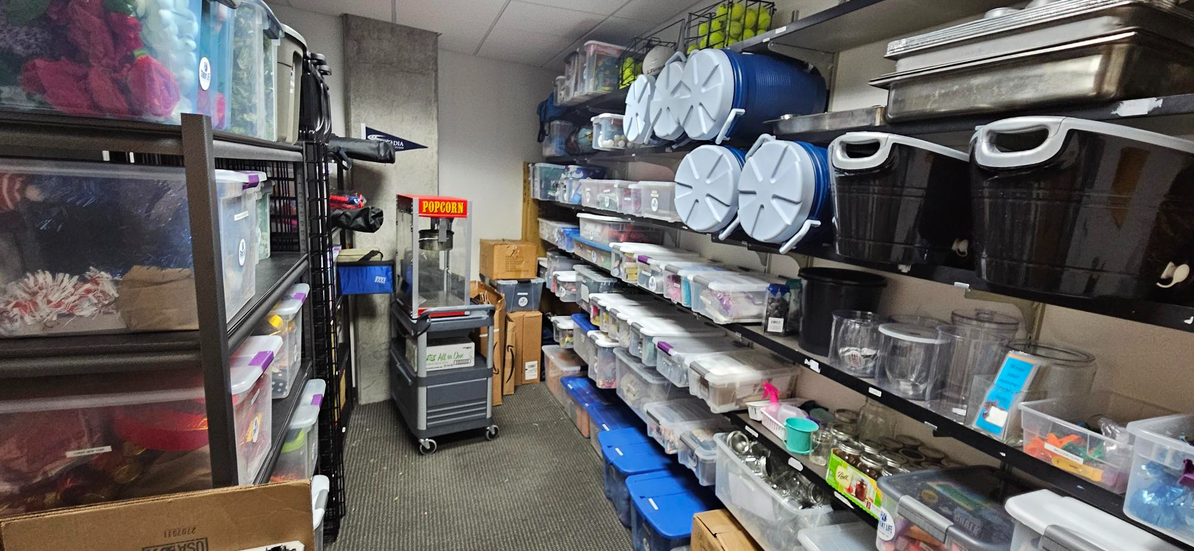
         2. No messes, Shandy will wrath (Dragon Fire) 🐲 all over you
         3. Great giveaways before check LBA before purchasing more giveaways or decor check it out
         4. LBA Carries Back Stock by popcorn machine, restock for plates, cups, and more compostables
         5. Make sure to clean up our spaces especially 142- Don't Cut Corners
   2. Becky Riopel
9. Committee reports
   1. ARC Advisory/SFAC -
      1. Jan 17th
   2. Bothell Dining Advisory Committee -
      1. Jan 10th
   3. Budget Council -
      1. Not Yet
   4. Campus Community Safety & Wellbeing Advisory Council -
      1. Not yet
   5. CC5 Public Art Committee -
      1. Jan 21st
   6. College Advisory Council -
      1. Cancelled meeting 1/6, next meeting Feb 3rd
   7. Commuter Services Advisory -
      1. Not yet
   8. Hazing Prevention Committee –
      1. Not Yet
   9. Information Security Management Council -
      1. Not Yet
   10. Student Learning Council -
       1. Jan 22nd
   11. Student Success Council
       1. Jan 21st
   12. Sustainability –
       1. Not yet
10. Unfinished business/New business:
    1. Advocacy Question of the week: What do we want to ask students this week?
       1. What’s your highlight from break?
       2. How was your enrollment process? Enrolling in classes?
       3. **What events would you like to see this quarter?**
       4. **What are your preferable drinks during winter times?**
    2. Upcoming Tabling dates
11. Announcements:
    1. 25th Anniversary of Cascadia- Student Life is putting something together with a graphic created. To engage with students the thought is to make an interactive wall. Especially at the Winter Involvement Fair. How would EAB want to engage with designs.
    2. [EVENT Planning](https://www.canva.com/design/DAGNHH9OPBU/XhhmdCybOdyp_xy9vVIB9w/edit?utm_content=DAGNHH9OPBU&utm_campaign=designshare&utm_medium=link2&utm_source=sharebutton) Time today after the meeting adjourns
    3. Darin is Starting Next Week
    4. Lunar New Year February 12th event time change 3-5pm
    5. Common Hour starts next week
12. Adjournment: 4:36pm

