EAB Meeting Minutes

Time 3:30 PM | Date 4/2/2025| Location ARC 110

1. Call to order: 3:33pm
2. Roll call of EAB members
   1. Advocacy Chair – Olivia Kent-Horton- Present
   2. Programming Chair – Leila De Folo-Present
   3. Molika Ny-Present
   4. Shaezel Khan-Present
   5. Taylan Allison-Present
   6. Jack McChesney-Present
   7. Darin Chung-Present
3. Approval of minutes
   1. Taylan motions to approve Jack seconds
   2. Motion Passes 6/0/0
4. Approval of agenda
   1. Taylan Motions to approve Darin
   2. Motion Passes 6/0/0
5. Open Forum
6. Special guests & funding requests
7. Member reports
   1. Advocacy Chair – Olivia Kent-Horton
      1. Delegation- EAB Coordinators -Send ICYMI Event summary/description to Advocacy Chair for inclusion in BOT report (don't forget to attend data requested in the description up top)
      2. 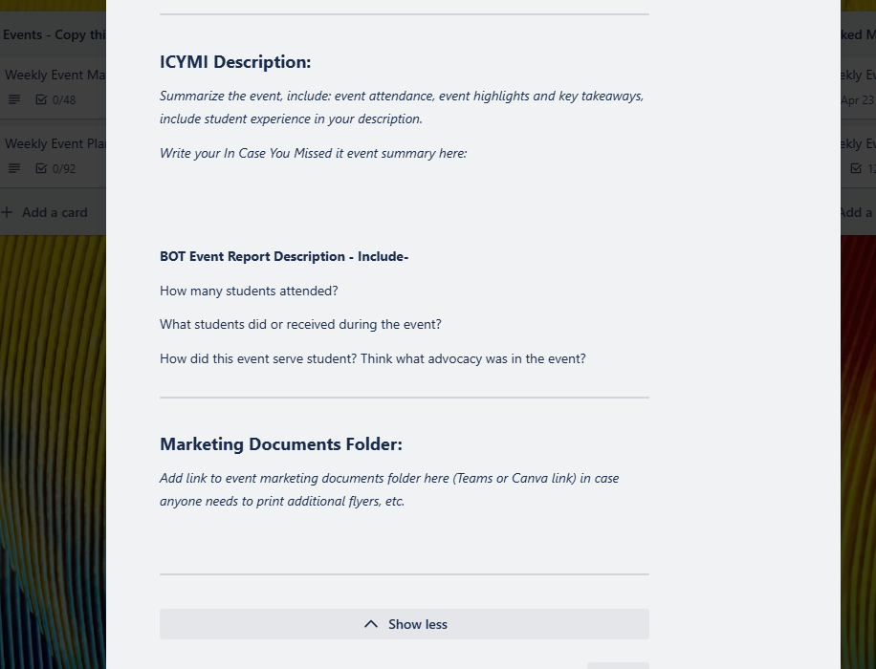
      3. BOT Updates- Board was interested in the events EAB was doing. Great comments on the MCing of the 25th Cascadia Celebration were given. Conversation about all Cascadia employees parking being covered. I spoke about previous student perspectives from a survey collected last year as well as EAB’s opinion on the idea and student parking fee increases.
      4. Meeting Minutes Calendar- if you need to change dates or the schedule please tell me now.
      5. I will be out of the office on Thursday and Friday this week.
   2. Programming Chair – Leila De Folo
      1. Please update your office hour schedule by this Friday so I can print the most recently updated version. Teams Leila for updates and the specifics.
      2. New due date for adding things to the EAB agenda is Tuesdays at 1:15 PM, if you need to add something after this let me know and add it directly to the agenda.
   3. Molika Ny
   4. Shaezel Khan
   5. Taylan Allison
      1. Update on Sexual Violence A event
         1. Innovation hall- club council space
         2. Screening movie “50 First Dates”- with interactive activities and conversational things about consent around the movie
         3. This is a collaboration with Violence Prevention, Title 9, and
         4. Movie is free and partners are covering snacks- Goodie bag, mini sandwiches, drinks
         5. EAB will be having the popcorn machine

Ideas to add the event

1. Giveaway for attendees
2. New Marketing Strategies
   1. Teams Taylan any ideas you have.
   2. Jack McChesney
      1. Review Spring Involvement Fair [agenda](https://cascadiacc.sharepoint.com/:w:/s/CascadiaStudentLife-ClubCouncil/EV-wKIkzWU1AlmQ1ejcZyCUBvWSMW2jZ1Fwa87-VdqxHnQ?e=63cL6V)
      2. Go over Club Involvement Initiative Student Questionnaire
   3. Darin Chung
3. Advisor reports
   1. Shandy Stomieroski
      1. There is now an ICYMI checklist on the EAB Trello Marketing Checklist to help keep track of the tasks that need to be completed (it is no longer on the planning list, it is on the marketing list)
   2. Becky Riopel
      1. HEDS Survey - closes April 14
      2. Campus Climate Survey already sent out to students through email
      3. First time survey was completed less student feedback 47 student responses
      4. This survey is important to complete for students.
      5. Can market at the EAB Table during Spring Involvement Fair
4. Committee reports
   1. ARC Advisory/SFAC - not yet
   2. Bothell Dining Advisory Committee - Friday Apr 4th @ 10
   3. Budget Council - April 8th
   4. Campus Community Safety & Wellbeing Advisory Council - Not yet
   5. CC5 public art committee - Not Yet
   6. College Advisory Council - April 7th
   7. Commuter Services Advisory - not yet
   8. Hazing Prevention Committee –not yet
   9. Information Security Management Council - Not yet
   10. Student Learning Council - no representative
   11. Student Success Council – no representative
   12. Sustainability - Not yet
5. Unfinished business/New business:
   1. Advocacy Question/Task of the Month: Common Hour Surveys (What are you hearing students say?)
      1. Spring Involvement Fair- Jack finding student feedback on clubs.
      2. Marketing HEDS Survey
   2. Upcoming Tabling dates
6. Announcements:
   1. Shaezel and Jack have looked at meetings in Trello can the cards be copied on the top.
7. Adjournment: 4:25pm