How to Find Notes from Assigned Notetaker in Accommodate

Turning on Accessibility Mode for Screen Readers Users
- Log into Accommodate using your Cascadia student email and password.
- Tab to “User Menu button”. Press Enter.
- Tab to “Accessibility Mode” option, press Enter.
- Press Enter on “OK” button.

Find Notes from Notetaker in Accommodate
- Log into Accommodate
- Select the Note-Taker Network option on the left side panel
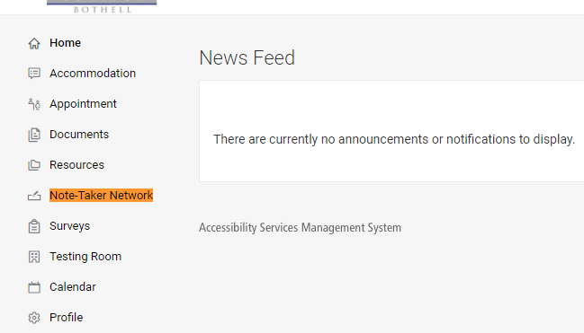
- Make sure the semester is the current quarter
- Your notes should be displayed and ready for you to download.
