How to Request Letter of Accommodation in Accommodate

Turning on Accessibility Mode for Screen Readers Users
- Log into Accommodate using your Cascadia student email and password.
- Tab to “User Menu button”. Press Enter.
- Tab to “Accessibility Mode” option, press Enter.
- Press Enter on “OK” button.

Requesting Letter of Accommodation
- Log into Accommodate using your Cascadia student email and password
- Select Accommodation option on left side panel.
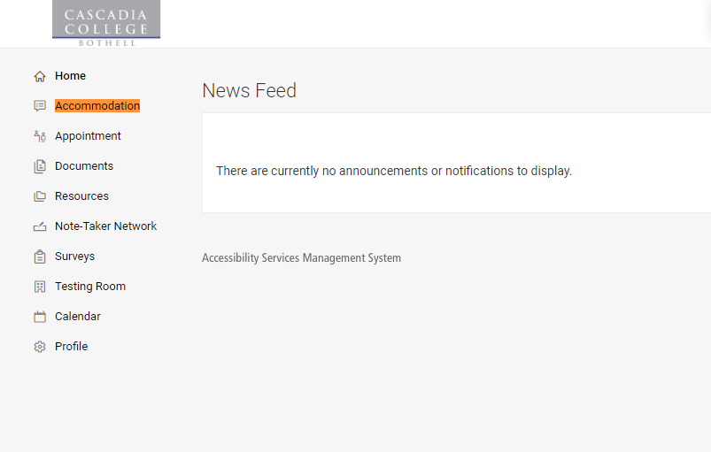

- Select Quarter Request from the drop-down menu
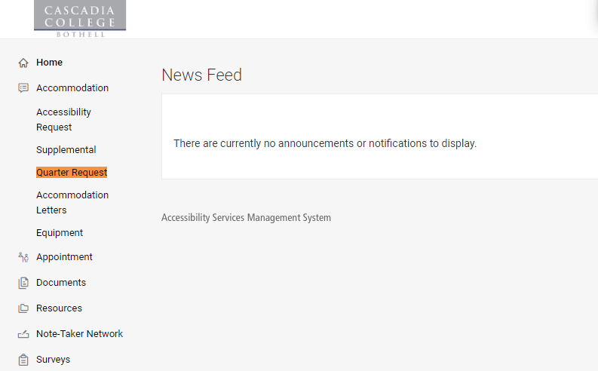
- Select the Add New button
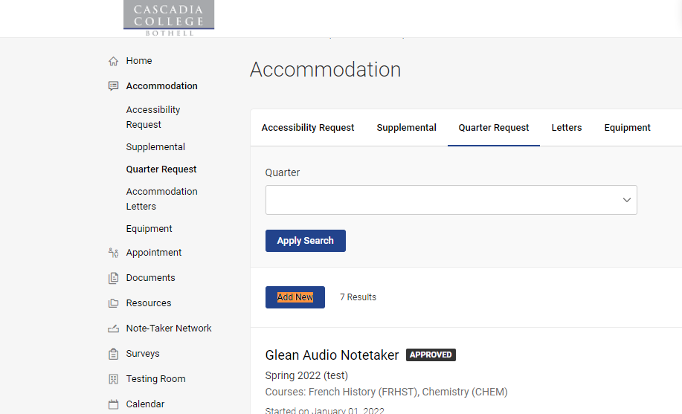
- Locate the Quarter drop-down menu and select the quarter you are requesting accommodations for.
- Select the Review the Renewal button.
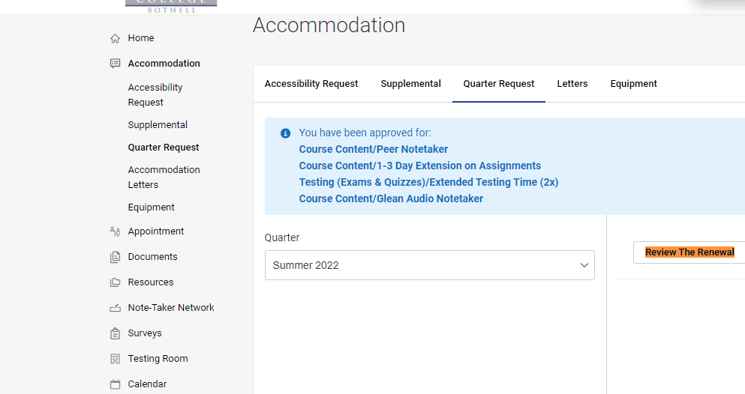

- Review the Accommodations listed on the page. Using the check-box option, select what accommodations you need for each of your courses. If you do not need a certain accommodation for a class, leave the box next to the class unchecked.
- Important: if you have the Peer Notetaker accommodation and you select the check-box next to your class in the Peer Notetaker section, Accommodate will automatically open a Peer Notetaker request to SAS. If you do not need a Peer Notetaker, please leave that section unchecked.
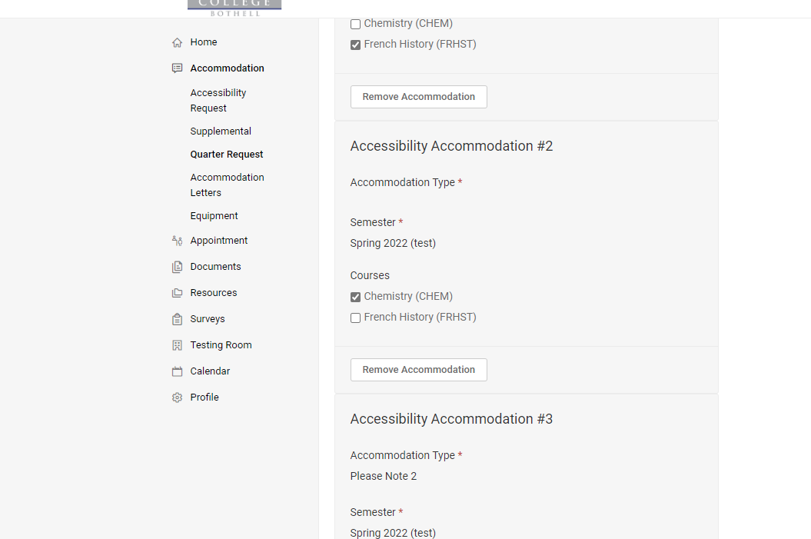

- Request a Peer Notetaker (if applicable): to request a peer notetaker for a class, in the Peer Notetaker accommodation section select the check-box next to the class in which you are requesting a peer notetaker. Accommodate will automatically open a Peer Notetaker request to SAS.
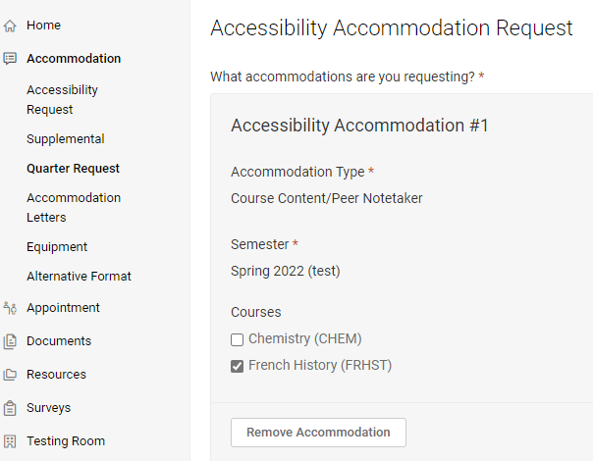
- If you do not need a specific accommodation for any of your classes, you can select the Remove Accommodation button (it will not be permanently removed or be deleted. You will still have that option for the future.)
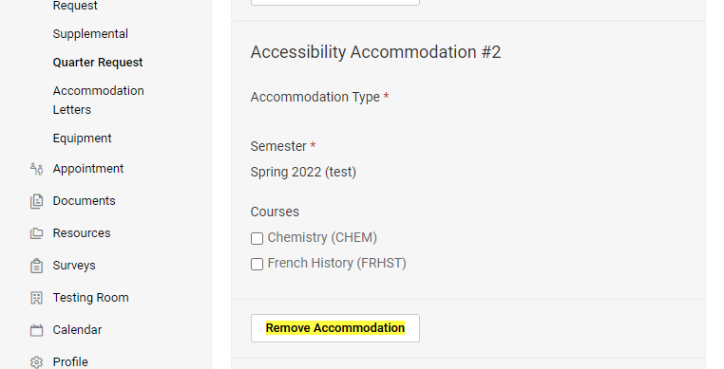

- Select Submit button once you are finished
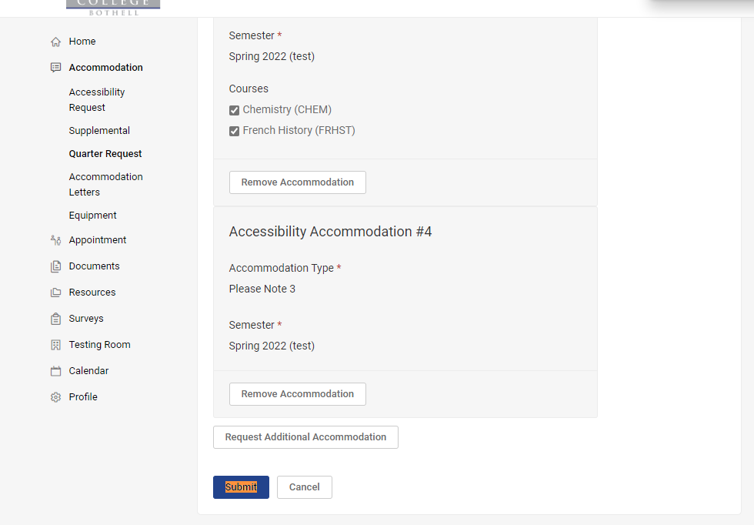
- You will now be able to review what accommodations you requested for each class.
