How to Request a Peer Notetaker in Accommodate

Turning on Accessibility Mode for Screen Readers Users
- Log into Accommodate using your Cascadia student email and password.
- Tab to “User Menu button”. Press Enter.
- Tab to “Accessibility Mode” option, press Enter.
- Press Enter on “OK” button.

How to Request a Peer Notetaker in Accommodate
When you request your Letter of Accommodation (LOA) for each class, if you have the Peer Notetaker accommodation, you need to check the box for the Peer Notetaker while requesting your LOA for a class. This will automatically put in a notetaker request.
To request your LOA for a class and request a Peer Notetaker:
- Log into Accommodate using your Cascadia student email and password
- Select the Accommodation option on left side panel
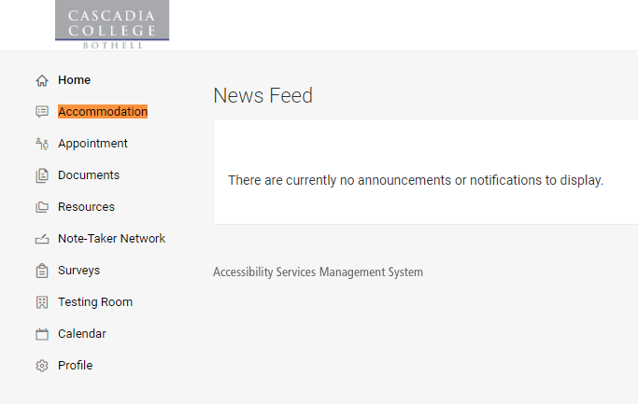

- Select the Quarter Request option from the drop-down menu
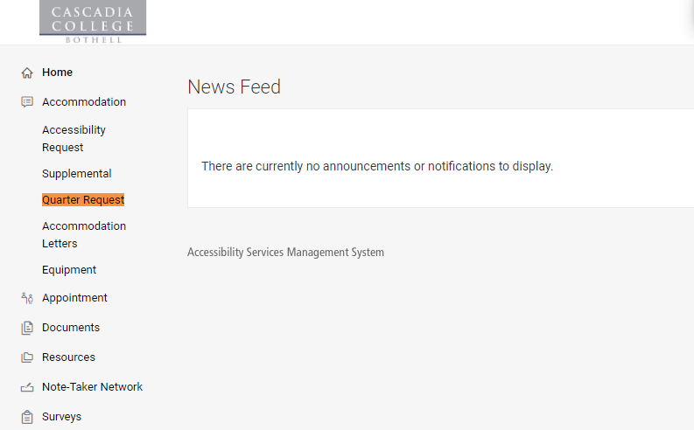
- Select the Add New button
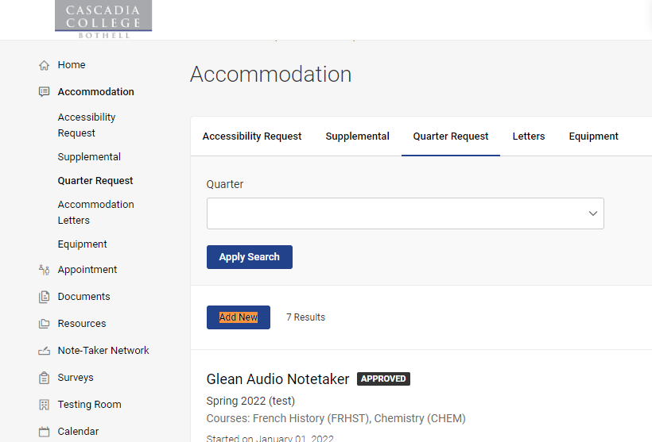

- Locate the Quarter drop-down menu and select the quarter you are requesting accommodations for.
- Select the Review the Renewal button. This will bring you to a new window that states, “What accommodations are you requesting?” Each accommodation that you have been approved for will display along with the classes you are registered for.
  - Review the Accommodations listed on the page. Using the check-box option, select what accommodations you need for each of your courses. If you do not need a certain accommodation for a class, leave the box next to the class unchecked.
  - Request a Peer Notetaker: to request a peer notetaker for a class, in the Peer Notetaker accommodation section, select the check-box next to the class in which you are requesting a peer notetaker. This will automatically submit a request to SAS.
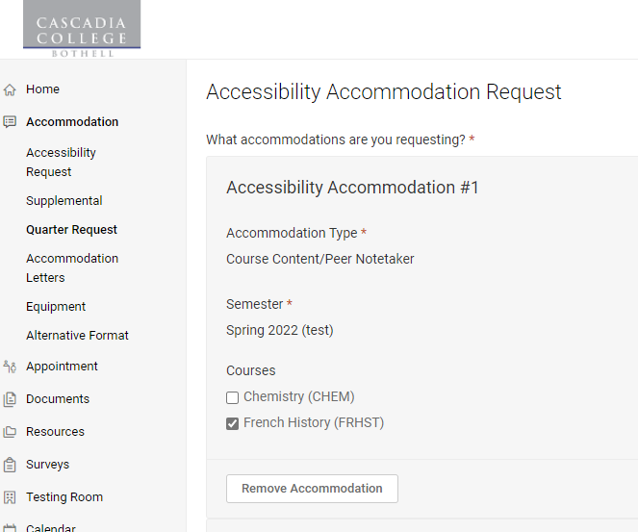
- Select the Submit button once you are finished
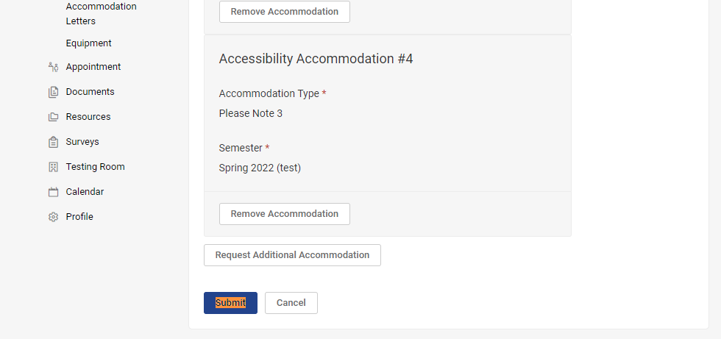
- You will now be able to review what accommodations you requested for each class.

