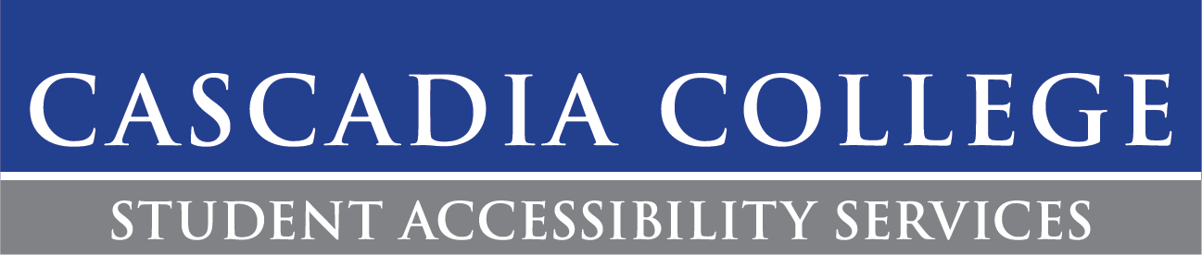

Introduction
Welcome to Cascadia College and to Student Accessibility Services (SAS)! Whether you are a new or returning student, here to obtain an Associates or Bachelor’s degree, or even take a couple of courses to enrich yourself, SAS is here to support you! SAS is located in Kodiak Corner (CC1-130) and is open Monday-Thursday from 9am-4pm and Fridays from 10am-2pm. We are closed on Fridays during summer quarter.
Cascadia College maintains SAS to provide accommodations and support services to students with disabilities in accordance with Section 504 of the Rehabilitation Act of 1973 and the Americans with Disabilities (ADA) Act of 1990 and Amendments of 2008. Our mission is to provide equal access and opportunity while promoting self-determination.
This handbook describes your rights and responsibilities as a student registered with SAS. We are excited to collaborate during this critical chapter in your life!
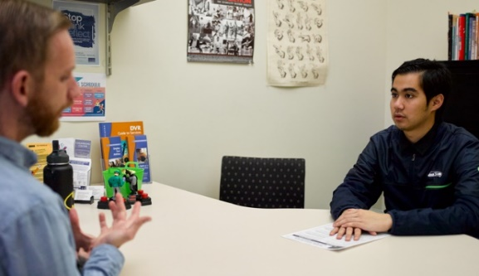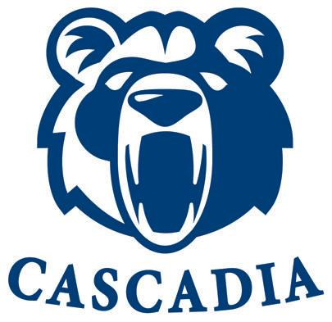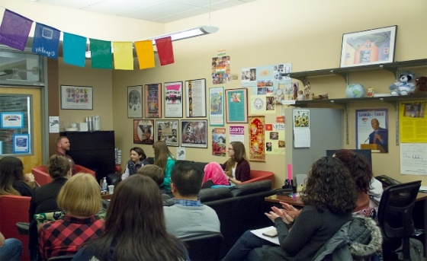

Registering with SAS:
To register with SAS and explore possible accommodations at Cascadia, please complete the processes below:
- Complete an Accommodations Application. Within this application, you’ll be asked to submit any documentation of a disability or diagnosis.
- Contact SAS to schedule an Access Meeting. The best way to schedule an Access Meeting is by emailing accessibility@cascadia.edu.
- During the Access Meeting you will meet with SAS staff to discuss potential accommodations. Through this interactive process, accommodations will be determined. Accommodations are determined on an individual basis and can vary from student to student.

Documentation
SAS will ask students to submit documentation of a disability or diagnosis. The documentation supports the process in determining accommodations. Documentation can be submitted by a licensed physician, primary health care provider, psychologist, audiologist, speech therapist, learning disability specialist, or other appropriate treating professional. IEP’s and service-connected disability evaluations are accepted.
Students are encouraged to contact SAS if they are having trouble acquiring documentation. If there is no documentation available, students are advised to still schedule an Access Meeting. Some accommodations can be determined without documentation if the disability or diagnosis is apparent. Depending on the nature of the accommodation request, further documentation may be requested.

Tips
- Before you start your first term at Cascadia, setup an Access Meeting with SAS.
- Students facing any challenges at Cascadia can meet with SAS to explore possible resources.
- Contact SAS if you are having trouble acquiring documentation of a disability or diagnosis.

Student’s Rights
SAS is committed to ensuring students are part of an inclusive environment where they are treated without biases. If a student feels there is an issue of access or they have been treated unfairly, please contact SAS.

Confidentiality
SAS complies and maintains confidential standards put forth by the federal government regarding any student documentation. A student’s disability or diagnosis will not be shared with faculty, however, the impact(s) of the disability or diagnosis may be discussed when consulting with faculty. SAS can only share information with a family member or guardian if the student has submitted a Release of Information Form to Enrollment Services. SAS will disclose confidential information if required to do so by court order, a disability related appeal is made, or the student has directed a threat upon themselves or others.

Cascadia College Non- Discrimination Statement & Complaint Procedure
Cascadia is committed to creating a supportive environment for a diverse student, faculty, and staff population. Individual differences are celebrated in a pluralistic community of learners. Cascadia does not discriminate on the basis of race, color, religion, gender and/or sex, sexual orientation, national origin, citizen- ship status, age, marital or veteran status, or the presence of any sensory, mental, or physical disability or genetic information and is prohibited from discrimination in such manner by college policy and federal law. If a student has been discriminated against because of their status, they can file a Discrimination Complaint with Cascadia’s Title IX/Equal Opportunity office.

Accommodation Appeal
In the event a student is not satisfied or disagrees with an accommodation that has been determined by SAS, the student can take the following steps:
- Schedule a meeting with the Director of Accessibility & Student Support Services. The Director will meet with the student to try and reach a resolution.
- If a resolution is not reached, the student can file an Accommodation Appeal, which will be evaluated by the Dean for Student Success Services.

Accommodate
Students will manage their accommodations requests through their Accommodate Portal. Accommodate is the accommodation software SAS uses to manage accommodations. This is where students can login and request their previously determined accommodations. Important: Students can only access Accommodate with their Cascadia issued email address and password. Cascadia email addresses are created for students after they registered for their first quarter of classes at Cascadia and are sent via the email address students used to apply to Cascadia. If a student is having trouble accessing their Cascadia email address, please contact the Help Desk.

Letter of Accommodation (LOA)
To activate accommodations for an academic quarter, students need to request their Letter of Accommodation (LOA) through their Accommodate Portal. Students can select what accommodations they need for a course in Accommodate (SAS advises all students to consider what accommodations are needed for a course before making the request). LOAs recognize the student as being registered with SAS and state their accommodations. Students will not have a LOA sent out by SAS without a request from the student via Accommodate.
SAS will send students their LOAs one-week prior to the beginning of the quarter if the LOA is requested prior to the start of the quarter. LOAs will also be emailed to students’ instructors during this time. This is the official notification of when a student’s accommodations begin. If a student is unsure if they need accommodations for a specific class, SAS recommends waiting until the first week of the quarter to have a conversation with their instructor about what the class will entail and if accommodations are necessary. Important: Accommodations can be requested at any time during the quarter but, depending on the accommodation, may need time to implement. Accommodations are not retroactive and must be requested beforehand.

Instructor Conversation
SAS strongly advises students to discuss their accommodations with their instructor. This is a conversation which should be held during the first week of the quarter. This gives the student and the instructor an opportunity to discuss what accommodations would apply to a course and how they would apply to the course. It will help ensure both the student and the instructor understand the student’s accommodations will work in a course. Also, it is a great space for students to gather more information if accommodations are needed for the course (as mentioned above). The conversation can be held in a private manner before or after class, during the instructor’s office hours, or through an introductory email.

Updating Accommodations
Barriers can present themselves when we least expect them. If a student’s condition changes or worsens, please contact SAS. The student will meet with SAS staff to discuss possibly updating accommodations. SAS may request additional documentation to update a student’s documentation.

Tips
- Verify your accommodations have been requested through your Accommodate Portal.
- Stay in contact with SAS throughout the quarter. We are here to help no matter the size of the question.
- Faculty will not implement accommodations without a LOA, which is why it is important to complete a request.

Accessing Accommodations
Some accommodations require students to submit a request through Accommodate in order for SAS to properly schedule supports. Below are accommodations which fall into that category (Accommodations are determined on an individual basis and may not be applicable to all students):

Exam Accommodations
Students who need extra time on a timed exam/quiz or need a reduced-distraction testing environment will need to schedule tests through Accommodate. The scheduling request must be completed a minimum of 3 days before the test day. Each exam or quiz must be scheduled on an individual basis. Once the request has been approved, the student and their instructor will be automatically notified. Students will need to notify SAS of any date changes to timed exams/quizzes. Exams/quizzes taken in the SAS Testing Office will be proctored by a staff member with the use of Recording Cameras.

Timed Exam/Quiz
Exam or quiz intended to be completed in a single session (ex: 90 minutes to complete the exam/quiz). For online exams instructors may allow students to take an exam/quiz over an extended period (ex: 12 hours) but the exam/quiz must still be completed in a single session.

Untimed Exam/Quiz
Exams or quizzes that do not need to be completed in a single session and can be conducted outside of the classroom (ex: take home exam). Some students might have classes in which their untimed exam/quiz will have an open window of time (ex: 12 hours). These are typically setup to be taken online. Students are asked to plan accordingly and to take the assessment within the given timeframe. Extra time may not be needed, please contact SAS to determine if extra time is appropriate.

Note-Taking Services
SAS has several note-taking methods available for students (peer note-taker, Glean, Livescribe pen). If note-taking services are determined for a student, SAS staff and the student will determine which method would be appropriate for the student. Students will need to select to request their note-taking accommodation to use it on a quarterly basis. SAS advises students to request peer note-takers at the beginning of the quarter since it can take 1-2 weeks to recruit a peer note-taker. Students can access notes peers have taken via their Accommodate Portal.

Accessible Media Requests
Students who require accessible media textbooks can request to have digital versions of their textbooks from SAS. Common accessible media formats consist of but are not limited to PDF, RTF, increased font size, Braille, and MP3. Textbook requests can take up to 2-4 weeks to be completed, therefore students are advised to submit their requests to SAS before the new quarter starts if possible (proof of purchase or ownership is required). Students will submit Accessible Media Requests through Accommodate.

Accessible Furniture
The nature of certain disabilities require a specific type of table or chair. If you are eligible for accessible furniture, SAS Staff will place the appropriate furniture in your classroom(s) before the quarter begins. SAS will only place furniture once a student has requested their accommodations for the quarter.

American Sign Language Interpreters
SAS provides ASL Interpreters to students who qualify for the accommodation. ASL Interpreters must be requested a minimum of 4 weeks before the start of the quarter. This allows SAS to ensure ASL interpreters are secured for each request. Please review the Interpreting Policy if you are accessing this accommodation.

Tips
- If unsure about what accommodations you’ll need for a specific course, connect with your instructor.
- Arrive to the SAS Testing Center 10-15 minutes before your scheduled exam.
- Students can always find the information they need for the accommodation process on the SAS website.

Campus Resources
SAS is just one of many resources available to students on campus. We encourage every student to consider the following resources:

Academic Advising
Located in Kodiak Corner, Academic Advisors help students make sound decisions with their educational goals. Advisors support students with selecting classes, university transfer options, college application process, and career opportunities on a drop-in and appointment basis. To learn more about Academic Advising and the ways to meet with an advisor, visit the Academic Advising website.

Adaptive Technology Workstation
Located on the 1st floor in Cascadia/UWB Library, students can use this workstation to utilize some of the latest technology (Dragon, ZoomText) in the accessibility field. The workstation has many features so please stop by or learn more about Adaptive Technology on campus.

Benefits Hub Emergency Grant
For students in emergency financial need, Cascadia College has established the Benefits Hub Emergency Grant. In partnership with the United Way of King County, the grant provides financial assistance to student who are experiencing financial insecurity. The grant is designed to support with a variety of costs such as utilities, living expenses, transportation expenses, medical bills, childcare expenses, groceries, course materials, and more. The grant cannot support with rent or tuition. Awards are limited to $1,000.00 a quarter. Please submit an emergency funding application if you are interested in applying.

Bock Learning Center
Located in CC2-060, the Bock Learning Center offers students multiple resources for strengthening their academic skills. Tutoring support is provided in a range of subjects on a drop-in and appointment basis. Online tutoring appointments, group study spaces and technology resources are also available. Learn more about the Bock Learning Center and contact them by phone at 425-352-8229 or by emailing learningcenter@cascadia.edu.

CARE Team
Cascadia’s CARE Team is a collection of staff and faculty who work with Cascadia students when they are facing challenging situations. CARE Team members meet with students to collect information and determine what resources would be best to connect students with. The CARE Team will respond to reports within 24 business hours. For any type of emergency situation, please call 911 for an immediate assistance. The CARE Team supports students through a wide range of non-emergency situations including, emotional distress, mental health challenges, food insecurity, homelessness, financial insecurity, concerning behaviors, and challenges with academics. If you or someone you know could benefit from the CARE Team, please submit a CARE Team report.

Counseling Services
Located in UW1-080, offers short-term, mental health counseling free of charge to Cascadia students registered in the current quarter. The Counseling Center provides mental health related services to facilitate students’ adjustment to college and their personal growth. You can learn more about the Counseling Center or contacting them by phone at (425) 352-3183 or by emailing uwbcc@uw.edu.

Health & Wellness Resource Center & United Way Benefits Hub
Located in ARC 120, the HaWRC is a one-stop resource hub to help students thrive! The HaWRC connects students to on and off campus resources including housing and rental assistance, food resources, financial coaching, and information, health education, and wellness supplies. Learn more about all the various resources offered at HaWRC. You can also contact them by phone at 425-352-5190 or by emailing hawrc@uw.edu.

Kodiak Cave
Located in LB2-006, Kodiak Cave is a food resource on the Cascadia College campus. Kodiak Cave directly serves the student body of Cascadia. The mission of the Kodiak Cave is to end hunger on campus through nourishing meals, providing education, and resources to our community. Kodiak Cave currently operates as a “choice pantry,” meaning guests will be able to pick the food that best meets their needs. You can learn more about Kodiak Cave by visiting their webpage.

MySSP
MySSP gives students access to real-time, confidential mental health support, twenty-four hours a day, seven days a week. Services are available in multiple languages. MySSP counselors are licensed mental health therapists who are familiar with Cascadia and UW Bothell resources. Students can connect with MySSP through phone by calling 1-866-743-7732 (if calling from out the U.S. or Canada, dial 001-416-380-6578). Students can also chat online with a MySSP counselor on the MySSP website or on the app. Students can download the MySSP Apple App or the MySSP Google Play App.

Student Financial Services
Located in Kodiak Corner, students who have questions about Financial Aid or want to explore resources to support them with expenses can meet with one of our of specialists in Student Financial Services. You can learn more about Student Financial Services by phone at 425-352-8860 or by emailing finaid@cascadia.edu.

Veterans’ Resources
Located in CC3-227, the Veterans Resource provides veteran students a safe and welcoming environment that promotes a sense of community. Cascadia College was named a military friendly school by G.I. Jobs magazine. This honor puts Cascadia in the top 15% of colleges, universities, and trade schools nationwide who deliver the best experience for military students. Learn more about Veterans’ benefits and resources or contact them by phone at 425-352-8025 and by emailing veterans@cascadia.edu.

Violence Prevention and Advocacy Program
The Violence Prevention and Advocacy (VPA) program offers Confidential advocates support students who have been impacted by sex- and gender-based violence and harassment. We know that many students experience these types of harm both before starting and during their time in college. If that's true for you, confidential advocates can support you. If you don't have a personal experience, you likely know or will know someone who does. Come meet an advocate, learn about the support available to you and others, and find out how to join our support group, Grow Together.

