How to Schedule an Appointment

Turning on Accessibility Mode for Screen Readers Users
- Log into Accommodate using your Cascadia student email and password.
- Tab to “User Menu button”. Press Enter.
- Tab to “Accessibility Mode” option, press Enter.
- Press Enter on “OK” button.

How to Schedule an Appointment
- Log into Accommodate using your Cascadia email and password
- Select the Appointments option
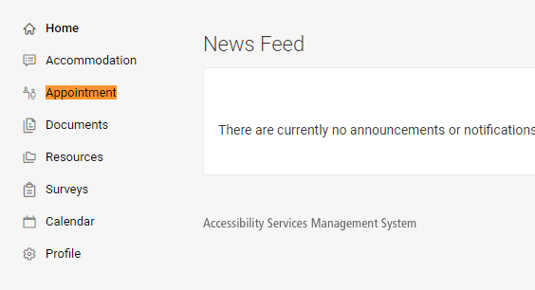

- Select the Request New Appointment button
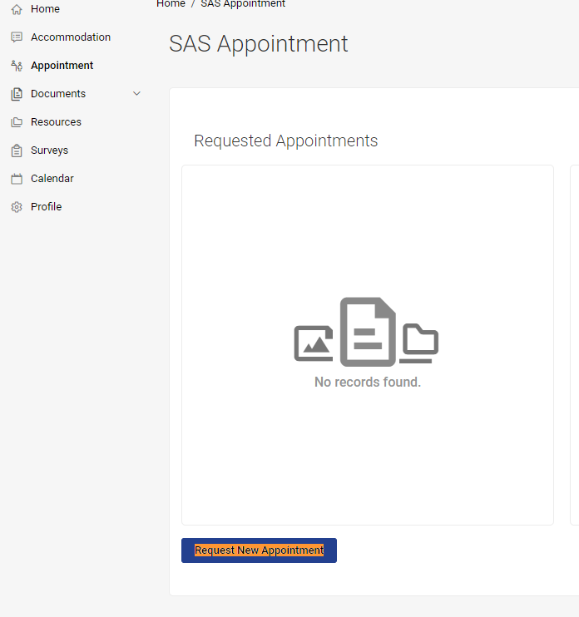
- Choose the Type of Appointment from the drop-down option
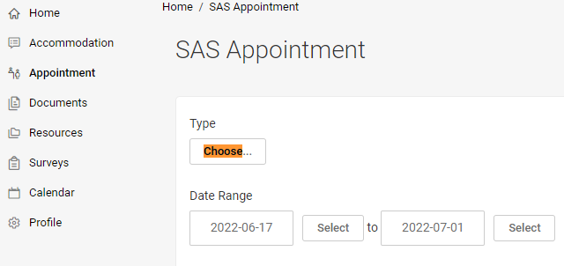

- Choose a Date Range by selecting the Select buttons
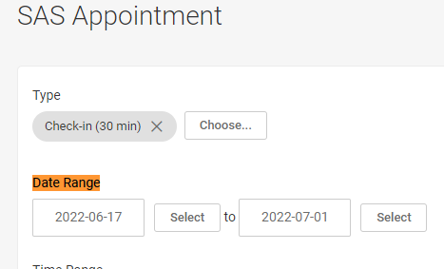
- Select a Time Range by selecting the hour, minutes, and am/pm drop-down options
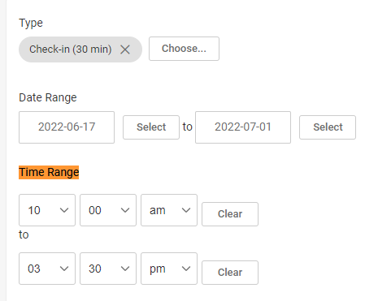
- Select the Location drop-down menu (Kodiak Corner or Virtual)

- In the Counselor section, select the check-box by the SAS staff member’s name in which you are scheduling an appointment with
- In the Days of the Week section, check the check-boxes next to the weekdays you prefer (Cascadia is closed on weekends)
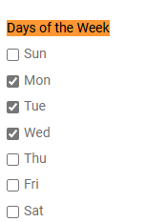

- Select the Check Availability button – a list of options will appear on the right
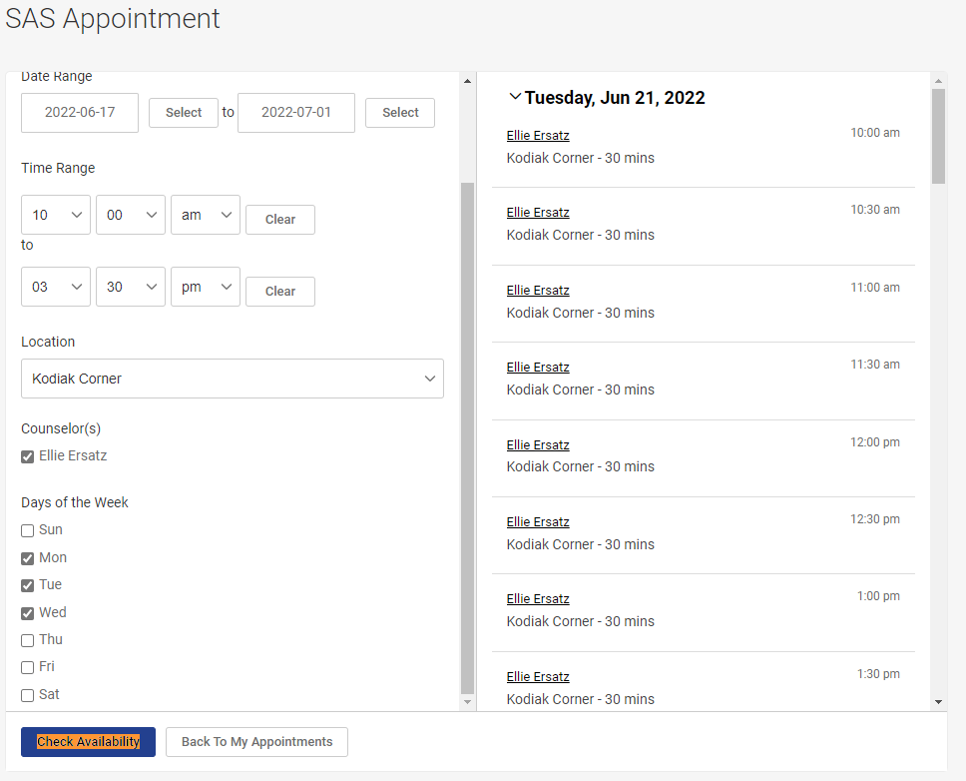
- Select the appointment option you want. A new window will appear. Double-check the information in the new window, and input whether you will need accommodations for the meeting (such as an ASL interpreter).
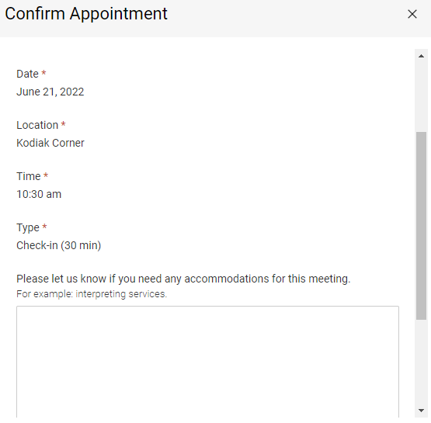
- Select the Submit Request button
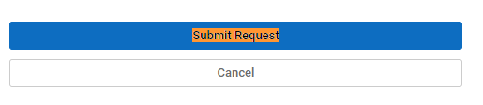
At any point if you need to cancel or reschedule your appointment:
- Select the Appointment option
- In the Requested Appointments section, your appointment will be displayed there.
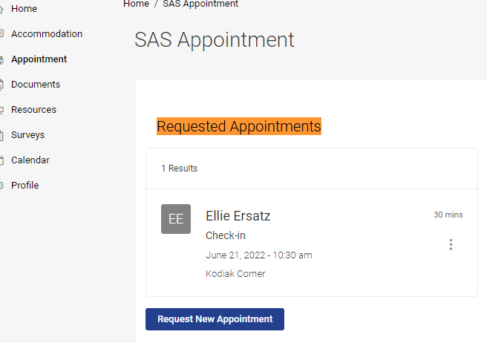

- Select the three dots button
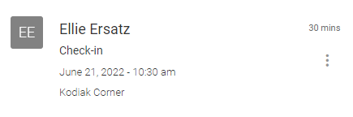
- Select the Cancel or Reschedule buttons
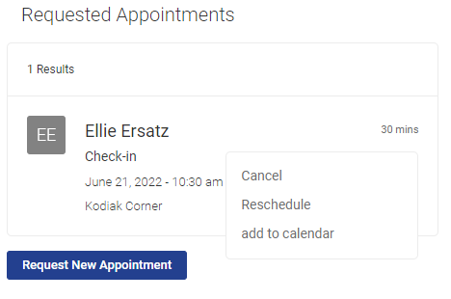
- Follow any remaining prompts

