# **How to Schedule your Tests in Accommodate**

**In-person and Online Tests**

Turning on Accessibility Mode for Screen Readers Users

1. Log into [**Accommodate**](https://cascadia-accommodate.symplicity.com/) using your Cascadia student email and password.
2. Tab to “User Menu button”. Press Enter.
3. Tab to “Accessibility Mode” option, press Enter.
4. Press Enter on “OK” button.

## **How to Schedule your Tests**

In order to use your testing accommodations, you must have requested your Letter of Accommodation (LOA) for the quarter. If you did not request your LOA you will NOT be able to proceed with scheduling your tests.

**Important**:

* At the earliest, you can begin scheduling your tests starting on the first day of a quarter.
* At minimum, you must schedule your test **72 hours prior to the test’s date**. If you try to schedule a test under the 72-hour limit, you will not be able to proceed. Please email SAS at [accessibility@cascadia.edu](mailto:accessibility@cascadia.edu).
* Make sure your test date & length is accurate. SAS and faculty will approve or deny the request.
* **Online Remote tests**: For tests that are online and remote, you will still need to follow the below instructions if you need your extended testing time accommodation (if applicable). Once you schedule your online exam, and after SAS has approved your request, your faculty will be notified to adjust your test time to double. In order for Accommodate to process your request and notify SAS and your faculty, you will still need to select a day and time even if your test can be taken any time within a given timeframe.

1. Log into [**Accommodate**](https://cascadia-accommodate.symplicity.com/) using your Cascadia student email and password
2. Select the **Testing Room** option on the left side panel

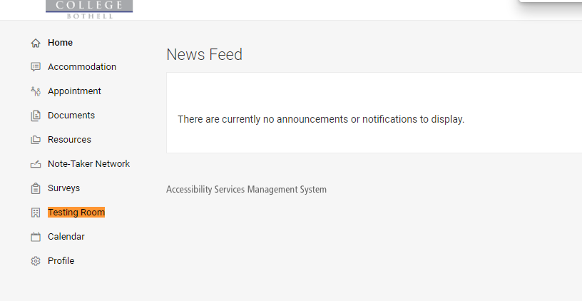

1. Select the **New Book Request** button

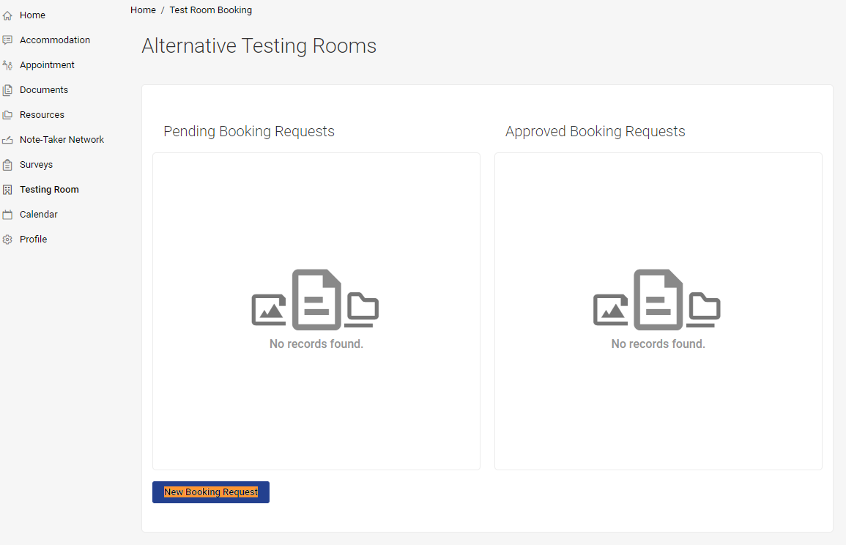

1. Choose your course from the **Course** drop-down section

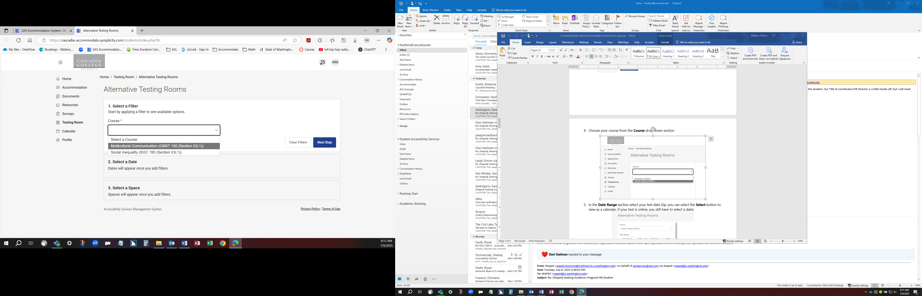

1. **Add Optional Filters.** In this section, you can choose the building (**Kodiak Corner** or **Online Remote Tests Only**), **Override Course Length**, and your testing accommodations you want to use.

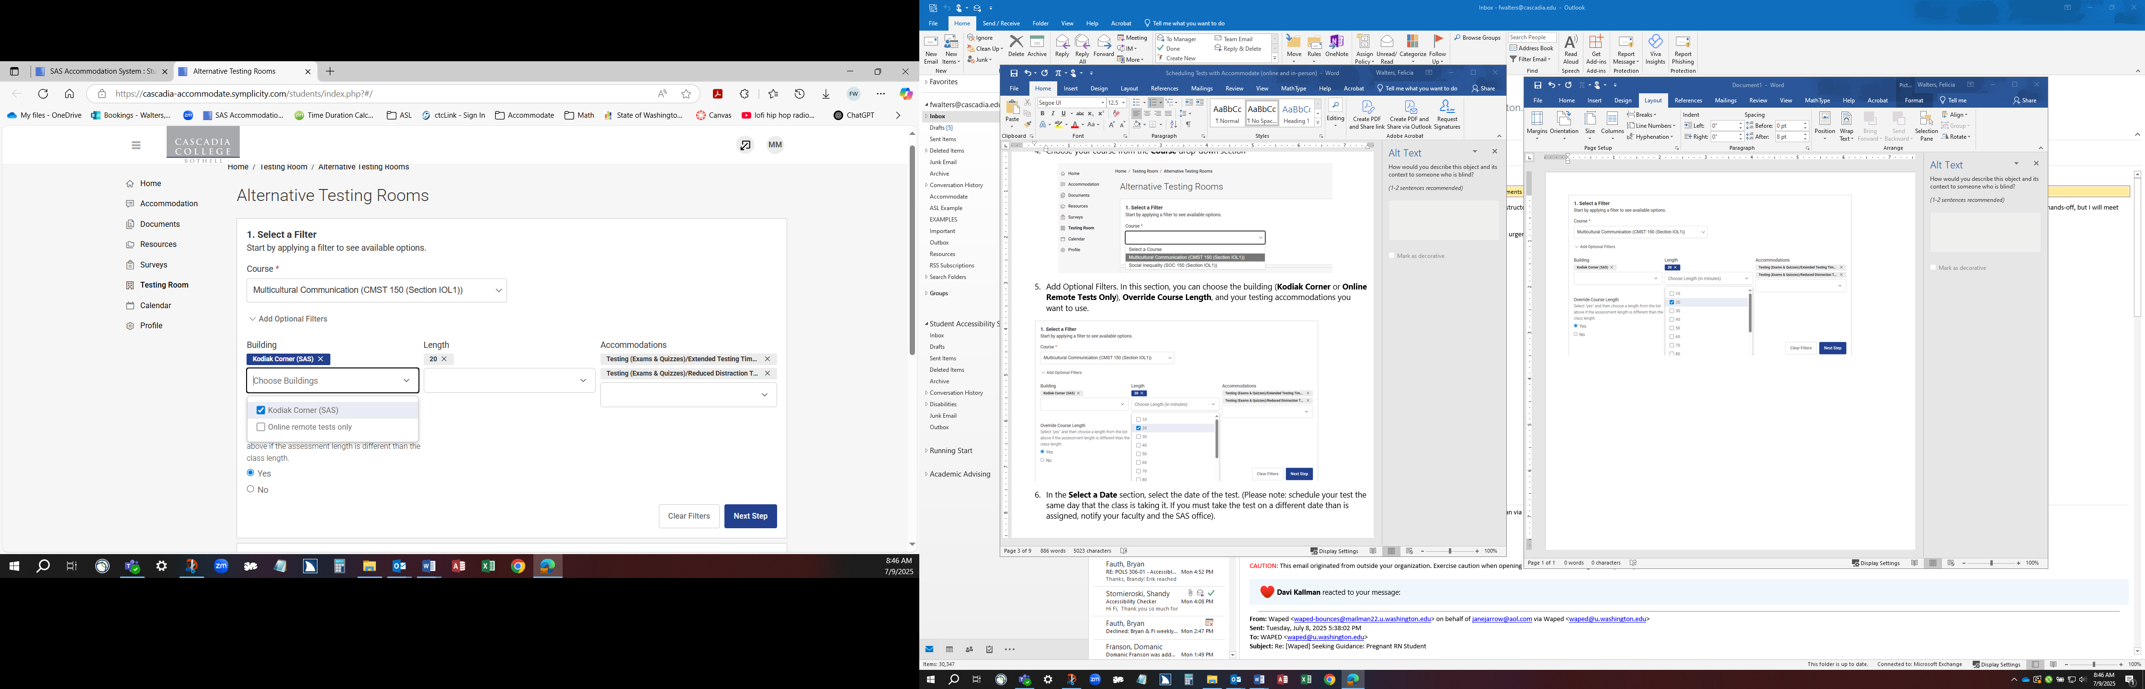

Please note: **Override Course Length Yes/No option**: Accommodate will automatically default to the whole class time for the exam (and double that for students with extended testing time; most classes are 2 hours & 5 minutes). **Short exams and quizzes will likely need an Override Course Length**.

* + If the class gets the whole class time to take the test, select the **NO** option. If the class **does NOT** get the whole class time for the test, select **YES** (This is common for quizzes and short exams in which the whole class time is not used)
  + If you select **yes**, please input the time that the class gets in minutes for the exams or quiz; Accommodate will double that for students with extra time.

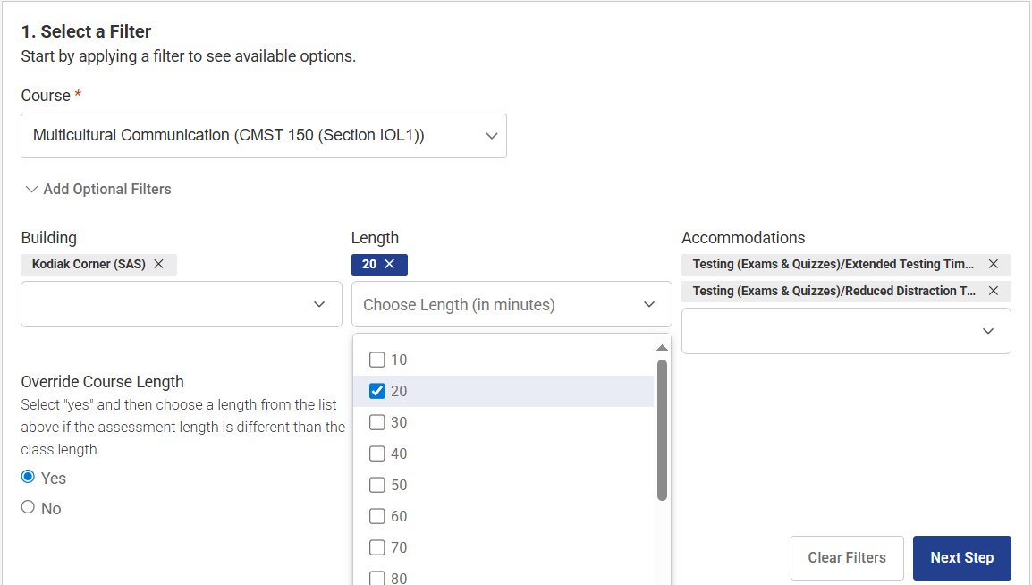

In the **Accommodation section**, all of your testing accommodations are already selected by default. If you do not need to use a specific testing accommodation, simply uncheck the box next the accommodation you do not want to use.

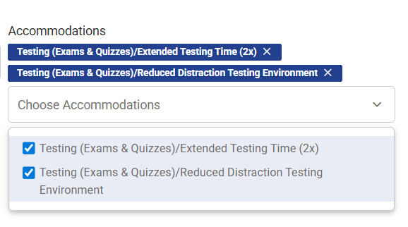

1. In the **Select a Date** section, select the date of the test. (Please note: schedule your test the same day that the class is taking it. If you must take the test on a different date than is assigned, notify your faculty and the SAS office).

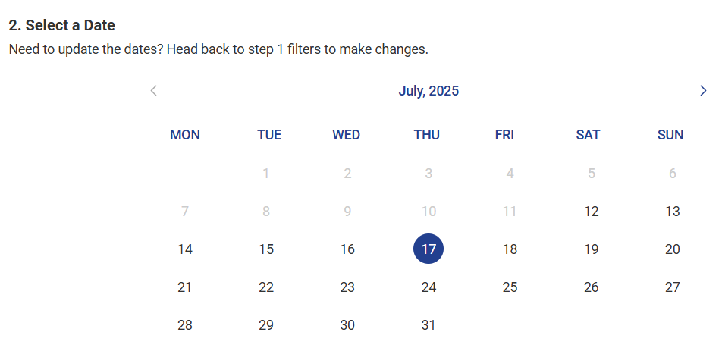

1. In the **Select a Space** section, select the appropriate space for your test. If your test is remote and online, select the **Online Remote Tests Only** option. If your test is on campus in-person, select the **Kodiak Corner (SAS)** option.

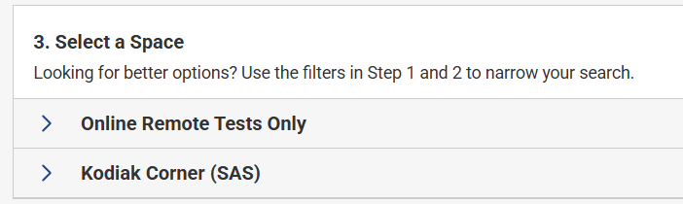

Once a space is selected, testing times will be shown. Select the time that you want to start the test by selecting the **Request button** on the right-hand side.

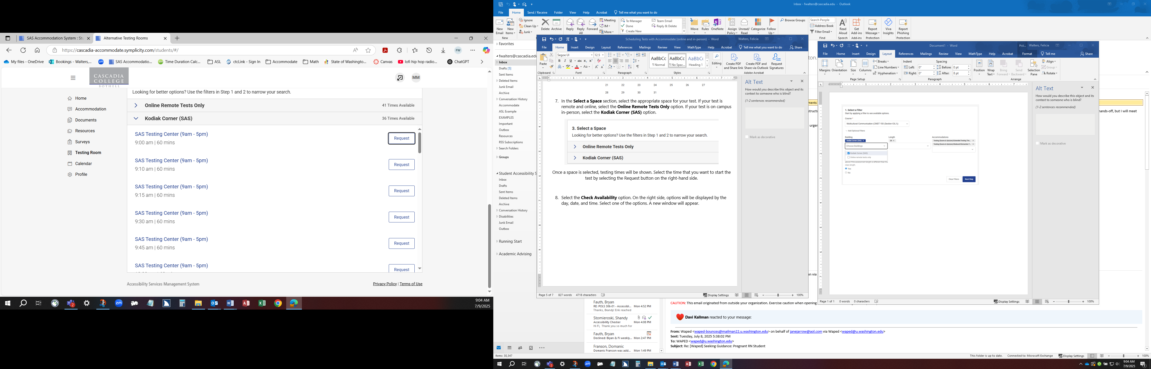

1. In the new pop-up window, please double-check the following information for accuracy:
   * Testing Room
   * Course
   * Date
   * Testing Time
   * Testing Length (includes extended time if you have that accommodation)
   * End Time
   * Is this an online test: select **No** or **Yes**
   * Accommodations Needed
   * In put any short notes that are relevant to the test

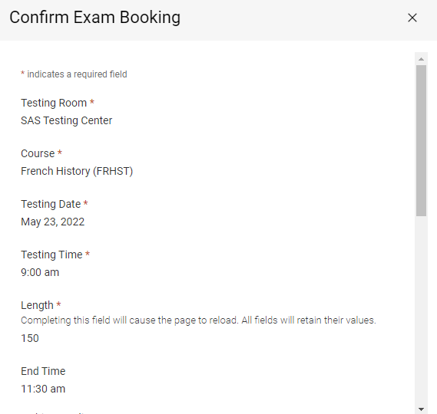

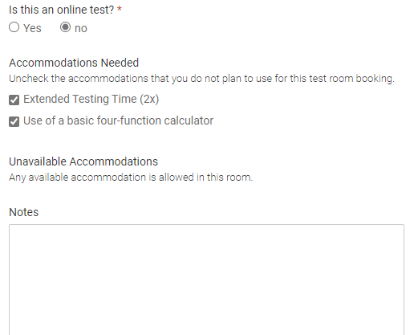

1. Select the **Submit Request** button on the bottom



It will now appear in the Pending Booking Request section (next to the Approved Booking Request). Once you have submitted the test room booking request, SAS and your faculty will need to approve it.

If applicable, if your test is online and remote your faculty will be notified to adjust your test time to double.

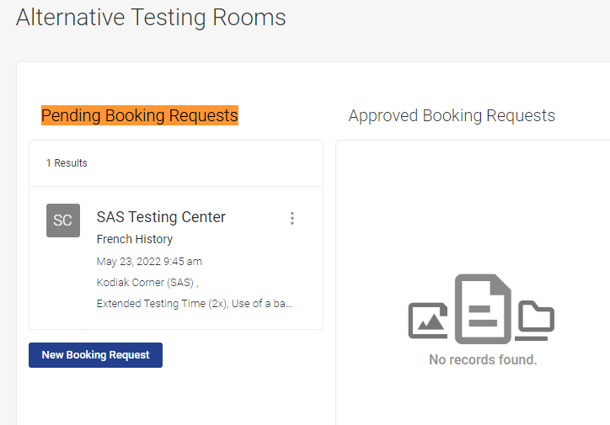

Notes:

* When scheduling, the default length of the test is going to be the length of the class (double that for students with extra time). If you are scheduling a test, such as a short quiz or an exam that is not given the whole class time, you will need to use **Override Course Length** and select the time in which the class gets for the test (for students with double-time, Accommodate will double it automatically).