How to Schedule your Tests in Accommodate
In-person and Online Tests

Turning on Accessibility Mode for Screen Readers Users
- Log into Accommodate using your Cascadia student email and password.
- Tab to “User Menu button”. Press Enter.
- Tab to “Accessibility Mode” option, press Enter.
- Press Enter on “OK” button.

How to Schedule your Tests
In order to use your testing accommodations, you must have requested your Letter of Accommodation (LOA) for the quarter. If you did not request your LOA you will NOT be able to proceed with scheduling your tests.

Important:
- At the earliest, you can begin scheduling your tests starting on the first day of a quarter.
- At minimum, you must schedule your test 72 hours prior to the test’s date. If you try to schedule a test under the 72-hour limit, you will not be able to proceed. Please email SAS at accessibility@cascadia.edu.
- Make sure your test date & length is accurate. SAS and faculty will approve or deny the request.
- Online Remote tests: For tests that are online and remote, you will still need to follow the below instructions if you need your extended testing time accommodation (if applicable). Once you schedule your online exam, and after SAS has approved your request, your faculty will be notified to adjust your test time to double. In order for Accommodate to process your request and notify SAS and your faculty, you will still need to select a day and time even if your test can be taken any time within a given timeframe.

- Log into Accommodate using your Cascadia student email and password
- Select the Testing Room option on the left side panel

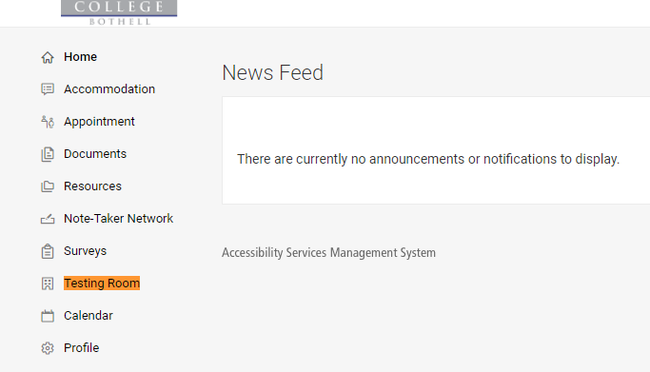
- Select the New Book Request button
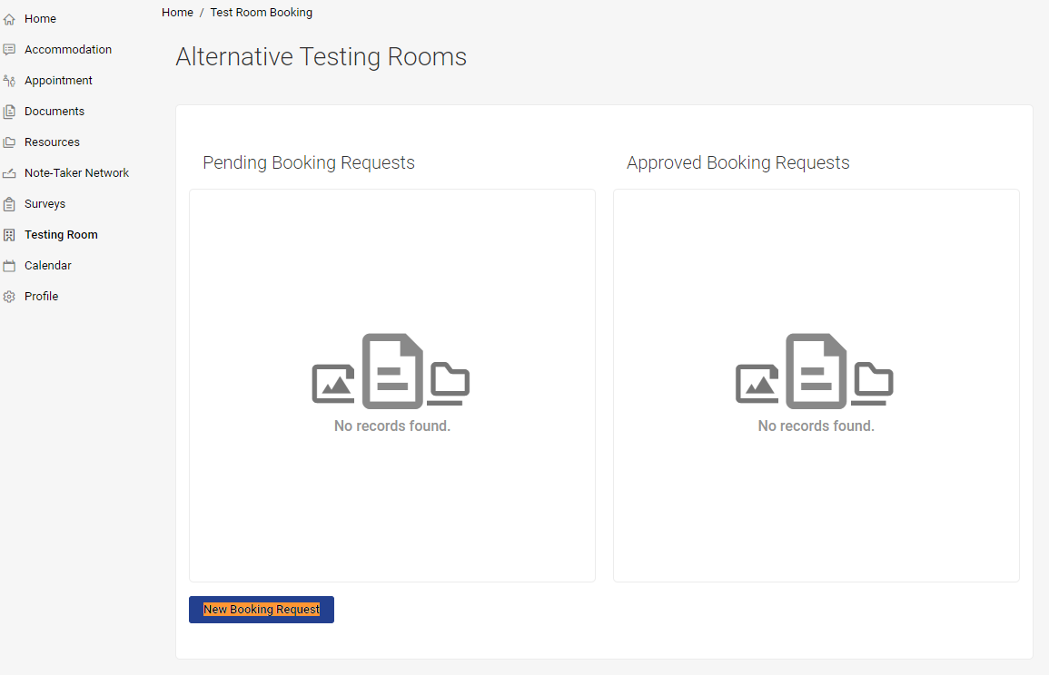

- Choose your course from the Course drop-down section
- In the Date Range section select your test date (tip: you can select the Select button to view as a calendar; if your test is online, you still have to select a date)
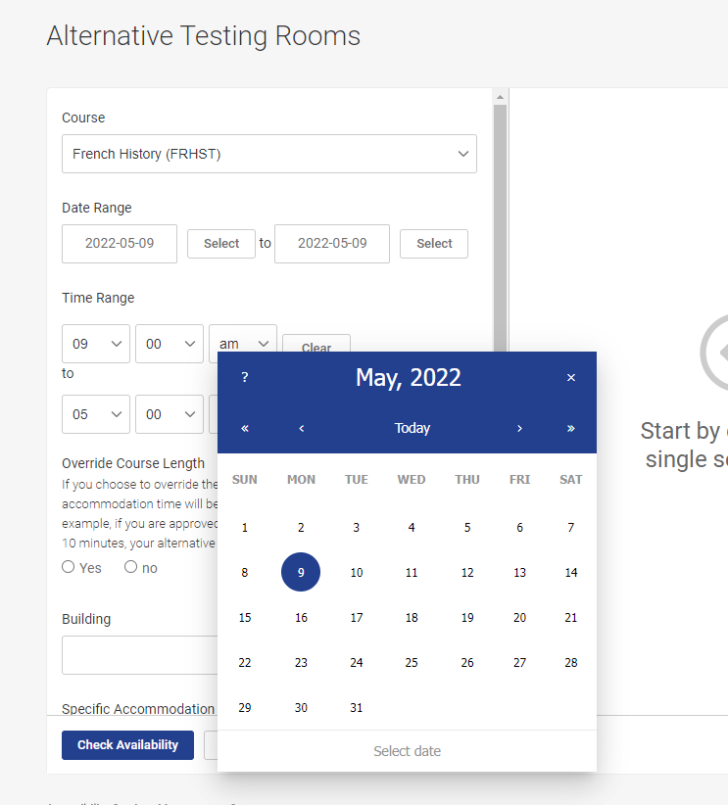

- Select a Time Range from the drop-down options in which you can take a test (only times/days that SAS is open are displayed). If your test is online, you still have to select a time.

- Override Course Length Yes/No option: Accommodate will automatically default to the whole class time for the exam (and double that for students with extended testing time; most classes are 2 hours & 5 minutes). Short exams and quizzes will likely need an Override Course Length.
  - If the class gets the whole class time to take the test, select the NO option
  - If the class does NOT get the whole class time for the test, select YES (This is common for quizzes and short exams in which the whole class time is not used)
    - If you select yes, please input the time that the class gets in minutes for the exams or quiz; Accommodate will double that for students with extra time.
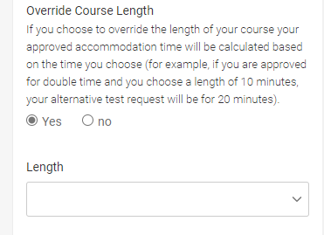

- In the Building option select Kodiak Corner (SAS) or Online remote tests only

- In the Specific Accommodation Required section, make sure all the testing accommodations you want to use are added by selecting the Add button (all approved testing accommodations are selected by default). If you do not need a certain testing accommodation, select the X button next to it.
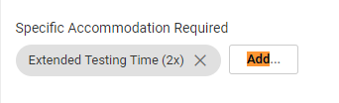
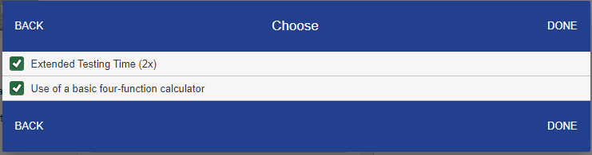

- In the Rooms section, select the SAS Testing Center option (if your test is on Friday then select the SAS Testing Center (Fridays) option). If your test is online and remote, select the Online Room (not proctored by SAS) option.
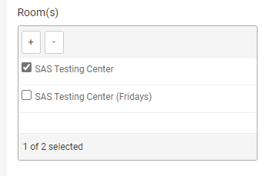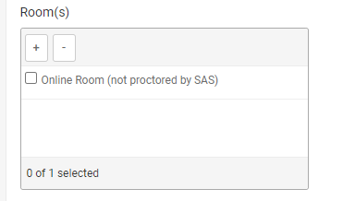
- In Days of the Week, select the check-box on weekday that the test is on.
  - Note: If your test is on a Friday, please only check Friday.
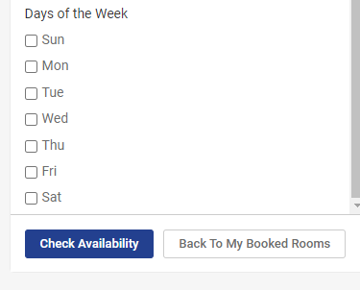
- Select the Check Availability option. On the right side, options will be displayed by the day, date, and time. Select one of the options. A new window will appear.
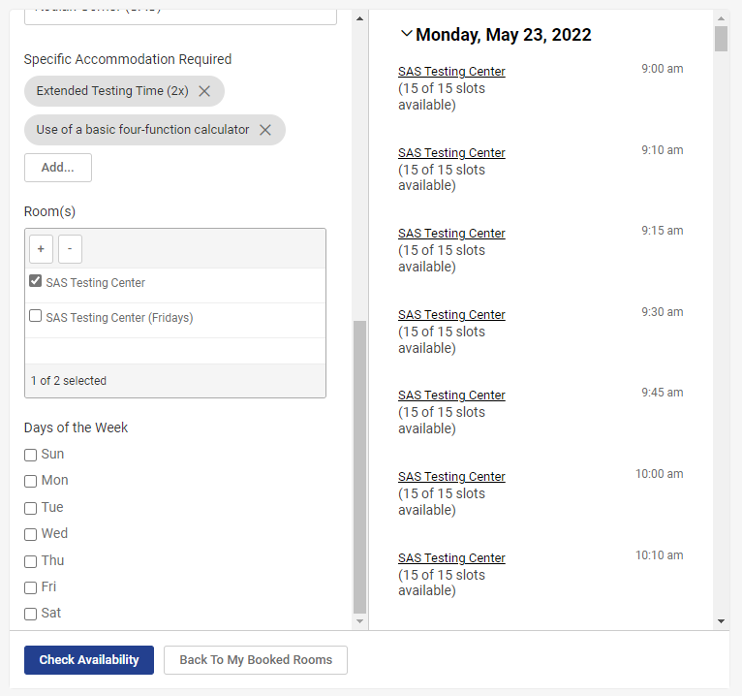

- In the new pop-up window, please double-check the following information for accuracy:
  - Testing Room
  - Course
  - Date
  - Testing Time
  - Testing Length (includes extended time if you have that accommodation)
  - End Time
  - Is this an online test: select No or Yes
  - Accommodations Needed
  - In put any short notes that are relevant to the test
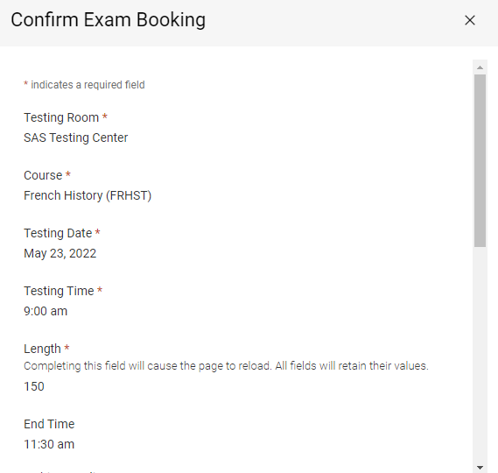
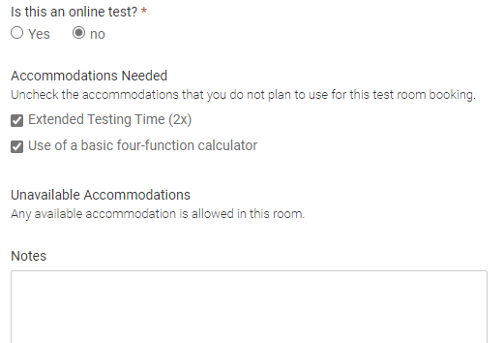
- Select the Submit Request button on the bottom

It will now appear in the Pending Booking Request section (next to the Approved Booking Request). Once you have submitted the test room booking request, SAS and your faculty will need to approve it.

If applicable, if your test is online and remote your faculty will be notified to adjust your test time to double.

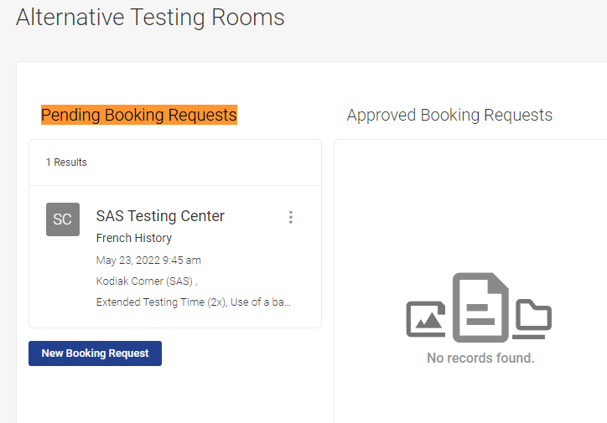
Notes:
- When scheduling, the default length of the test is going to be the length of the class (double that for students with extra time). If you are scheduling a test, such as a short quiz or an exam that is not given the whole class time, you will need to use Override Course Length and select the time in which the class gets for the test (for students with double-time, Accommodate will double it automatically).

