How to Submit Accessible Media Format Requests

Turning on Accessibility Mode for Screen Readers Users
- Log into Accommodate using your Cascadia student email and password.
- Tab to “User Menu button”. Press Enter.
- Tab to “Accessibility Mode” option, press Enter.
- Press Enter on “OK” button.

How to Submit an Accessible Media Format Request
- Log into Accommodate using your Cascadia email and password
- Select the Accommodation option on the left side panel
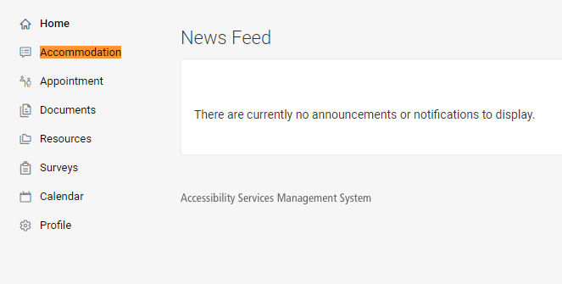
- Select the Alternative Format option from the drop-down menu
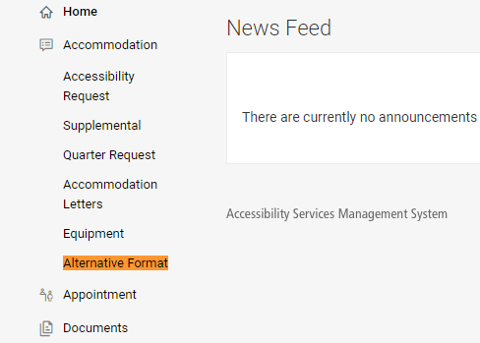

- Select the Student Entered tab
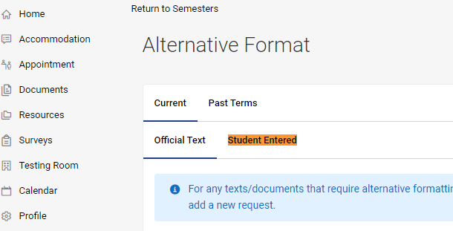
- Select the Upload Document for Alternative Format Request button
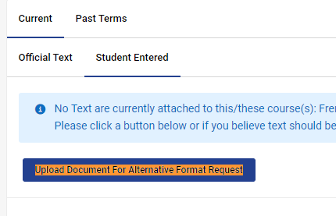

- Enter the following information:
  - ISBN-13 of the book
  - Title
  - Author (optional)
  - Description (optional)
  - Select the current Quarter
  - Select the class the book is for
  - Upload Proof of Purchase/Proof of Access (ex: receipts, image of the book in your possession, etc.)

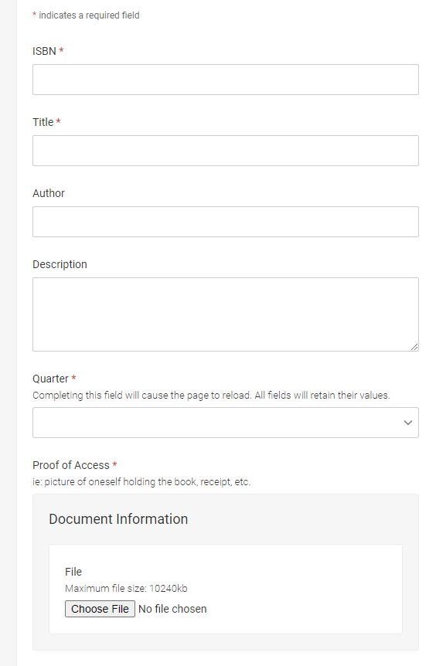
- In the Requested Types of Alt Text select Digital Format from the drop-down options
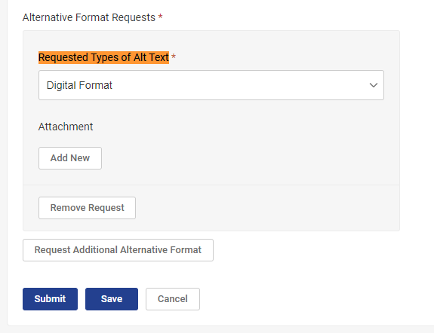
- Select the Submit button
