How to Submit a Supplemental Request

Turning on Accessibility Mode for Screen Readers Users
- Log into Accommodate using your Cascadia student email and password.
- Tab to “User Menu button”. Press Enter.
- Tab to “Accessibility Mode” option, press Enter.
- Press Enter on “OK” button.

How to Submit a Supplemental Request
- Log into Accommodate using your Cascadia email and password
- Select the Accommodation option on the left side panel
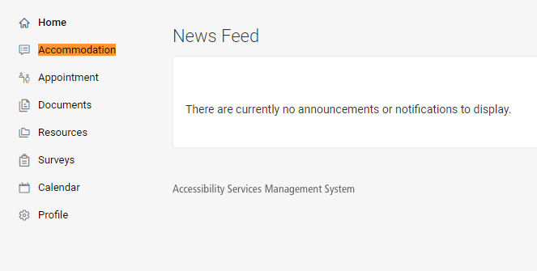
- Select the Supplemental option for the drop-down menu
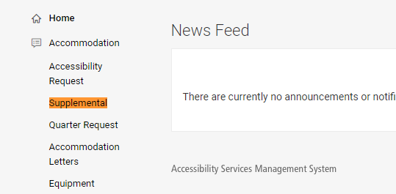

- Select the Add New button
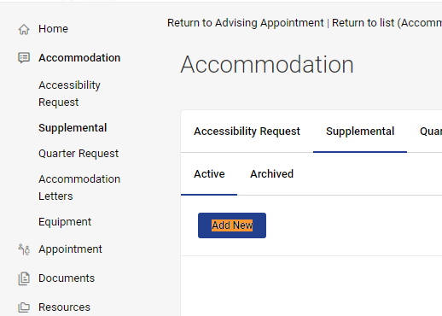
- Complete all the questions and upload supporting documentation, such as new documents from a doctor or other professionals.
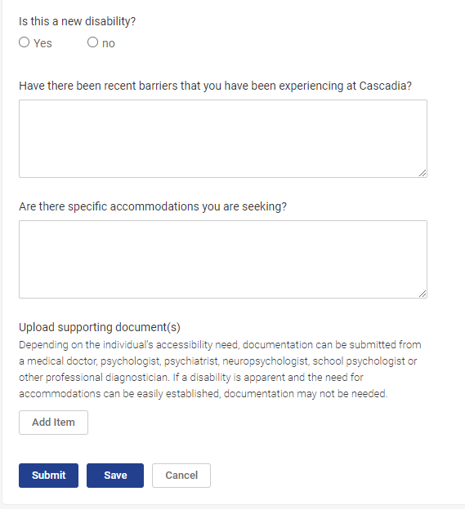
- Select the Submit button

Once you submit a Supplemental Request, an SAS staff member will contact you regarding scheduling an appointment to discuss your request.

