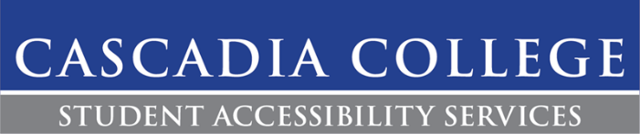

Recording Exams Policy

Description:
The SAS Testing Center uses video cameras to effectively proctor exams. This allows SAS to serve a large number on of students at one time and ensure the integrity of each exam.

Procedures:
- Exams will be recorded if a student is taking an exam or quiz in the SAS Testing Center.
- Cameras will only have the ability to visually record, audio recordings are not permitted in the SAS Testing Center.
- To ensure student confidentiality and privacy, the Dean of Student Success will authorize select staff to have access to recordings.
- Students can request to view footage of their exam. Please note the process of viewing footage may take time as we need to ensure any other students in the footage have their image blacked out.
- If a student chooses not to uphold Cascadia’s Academic Honesty policy by cheating or plagiarism, the recordings will be shown to the involved faculty. Recordings can be used as documentation for violations of the Academic Honest policy and will be kept on file until the investigation has been completed. Recordings are subject to review by the Student Conduct Officer.

Contact:
If there are any questions or concerns regarding this accommodation, please contact SAS at 425.352.8261 or by emailing accessibility@cascadia.edu.

