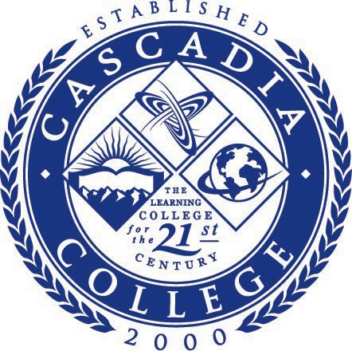

Board of Trustees Meeting Agenda

Dr. Colleen Ponto, Chair
Dr. Meghan Quint, Vice Chair
Ms. Angie Hinojos
Mr. Mike Kelly
Mr. Norm Seabrooks
Executive Session
Wednesday, January 4, 2023
4:00 p.m.

Cascadia College
Via ZOOM

Cascadia College Board of Trustees
Cascadia College
Via ZOOM

Wednesday, January 4, 2023

4:00 p.m.

AGENDA

- EXECUTIVE SESSION (4:00pm)
The Board will meet in a 90-minute Executive Session to discuss number 2
below and/or any of the issues listed below:
- to receive and evaluate complaints against a public officer or employee;
- to evaluate the qualifications of an applicant for public employment or to review the performance of a public employee;
- to discuss with legal counsel litigation or potential litigation to which the college is, or is likely to become, a party, when public knowledge of the discussion would likely result in adverse consequences to the college;
- to consider, as a quasi-judicial body, a quasi-judicial matter, between named parties;
- to consider matters governed by the administrative process act, chapter 34.05 RCW; and/or
- to plan or adopt the strategy or position to be taken during collective bargaining, professional negotiations, or grievance or mediation proceedings, or to review proposal made in on-going negotiations or proceedings.

- NEXT MEETING

  - The next regularly scheduled public meeting of the Board is Wednesday, January 18, 2023, 4:00pm.

The facilities for this meeting are free of mobility barriers. Interpreters for hearing-impaired individuals and taped information for visually impaired individuals will be provided upon request when adequate notice is given.

